Facebook posting parties

Message to send to customers to ask them to be a potential hostess:

Hey Crys! I know it’s been awhile since we’ve chatted. I hope you’re doing well and getting excited for summer! I wanted to reach out and see if you’d be willing to help me out. 🙏 I’m working really hard to (goal you are working on) and I’m so close I can taste it! lol

I was hoping you’d be willing to be a virtual hostess for me? It’s super easy, and I do ALL the work! Plus as a hostess you’ll receive 20% of party sales in FREE products and $25 for every party booked from your party.

As an added hostess bonus you’ll receive a free product of your choice worth up to $25 from me just for saying YES, too! 🙌 What do you say? Can you help me out! 💗

When they say yes, say:

Thank you for being willing to help! 💗🙌 I SO appreciate you!

It’s SUPER simple and easy. I do all the work all you have to do is invite some people.

I’ll create a private FB group & then you invite your family, friends & any FB friends you want to join the group. I would mail sample packs for free to whoever wanted to try some samples. I’d hop on FB and walk them through how to use the samples. Then you’d get tons of FREE products!! 😍

My family & friends have been having a blast with these virtual parties! 🥳 When typically works best for you days/evenings or weekends?!

⭐️ Book her for a date & time at least 1.5 - 2 weeks out so you have time to collect addresses & mail samples! ⭐️

Create the party group 2 weeks before the party (or the day you book it if it’s less than 2 weeks out). To create the group, go to Facebook > menu > groups > click on the + sign to create a new group

Group name:

Ash’s Spa Day w/ Mary Kay ~ Sunday, June 5th at 6pm EDT!

Group settings:

Private, visible

Description:

Welcome to Ash’s Spa Day w/ Mary Kay on Sunday, June 5th at 6pm EDT! 💕

You will get a pampering package full of samples to use during the FB Live party! The best part is that you will be in the comfort of your own home in your PJs and no one will see you because it's a FB Live event in this private group! 🙌

It's going to be fun with lots of beauty tips and we are even giving away prizes! 🎁

Please make sure to PM me your mailing address + skin type (normal/dry or combination/oily) so I can send you a pampering package with FREE samples inside!

💕Thanks for joining!💕

Welcome post:

Hello, fellow Beauty Lovers! 👋 My name is Lindsay Freisthler and I will be your Mary Kay consultant for Ash Moore’s Spa Day!

The virtual spa party will actually take place on Sunday, June 5th at 6pm EDT on Facebook (in this group), I will be going LIVE! You will be receiving a pampering package full of samples to use during the LIVE. 🧖‍♀️

I’ll be posting some pre-party posts that will help you get acclimated to me & MK and also give you chances to be entered into a drawing to win FREE PRODUCT DRAWING! 🎁

Anytime you see a 🎟 comment on that post and you’ll get entries for that drawing! Comment "HI" below to get your first entry! 🎟

Here’s all you need to know 👇

Send me your mailing address & skin type (normal/dry or combination/oily) so I can mail you a pampering package!

Reply to any post with a 🎟

Sit back, relax and check in daily to be entered to win FREE STUFF! 🎉

Join us Sunday 6/5 at 6pm EDT in this group for the FB Live Pampering party!

SHARE SHARE SHARE!!! Invite your friends to join us! For each friend that you invite, tag her name below and you get an entry for every friend! 💕
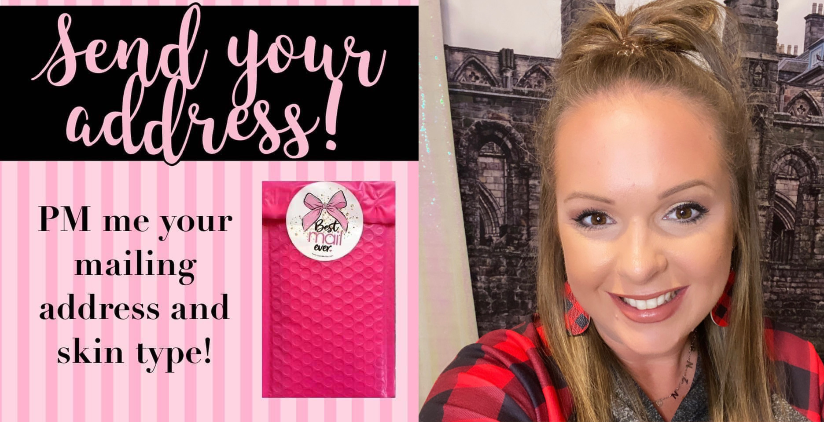

Message to send to the friends your hostess has invited into the group:

Hi Amy! 👋 thank you for joining Ash Moore’s virtual spa party! 🎉

My name is Lindsay and I'm the Mary Kay beauty consultant for her party. I would love to send you a pampering package full of FREE samples to use during the FB Live party Sunday 6/5 at 6pm EDT. It will just be me going live (so no one will see your face 😉) & then you’ll just hop on from the comfort of your own home to try the samples I send you!

Can I please get your address & skin type to send you a pampering package? (Normal/dry or combination/oily) 💖

When they reply back with their name & address, say:

Fabulous, I’ve got you down! 😍 have you ever tried Mary Kay before?

If they say no, say:

Awesome! I’m excited to be the one to introduce you to MK! 🙌 watch your mailbox for a fun package from me & save the date of Sunday 6/5 at 6pm to join in for the pampering! ☺️

If they say they’ve tried Mary Kay before, say:

Oh FUN!!! 😍 do you have a Mary Kay beauty consultant who is currently serving you? If so, I will happily still mail you free samples & you can buy something from the party to support Ash, but then I will refer you back to your consultant because we don’t steal customers from each other 💖

Below are the lead up posts to post in the group leading up to the party. Ideally you want to have one engagement post per day & one Mary Kay related post per day.

Lead up post #1: (this is the only post the first day)

WELCOME and thank you for joining Ash Moore’s virtual pampering party! 🥳

I’m so excited for our SPA NIGHT in a couple weeks! How this works is I’ll mail you FREE samples & we’ll all get to pamper ourselves from the comfort of our own homes right here on a Facebook Live party together! 😍 it’s the “new school” Mary Kay party instead of getting together around a kitchen table! ☺️

SHOUT OUT & welcome to our new members:
(Tag all new members of the group) & of course, (hostess name)!!! 👋

Please make sure to PM me your address & skin type (combination/oily or normal/dry) so I can mail you a pampering package full of FREE samples for the FB Live party Sunday 6/5 at 6pm! 🥳

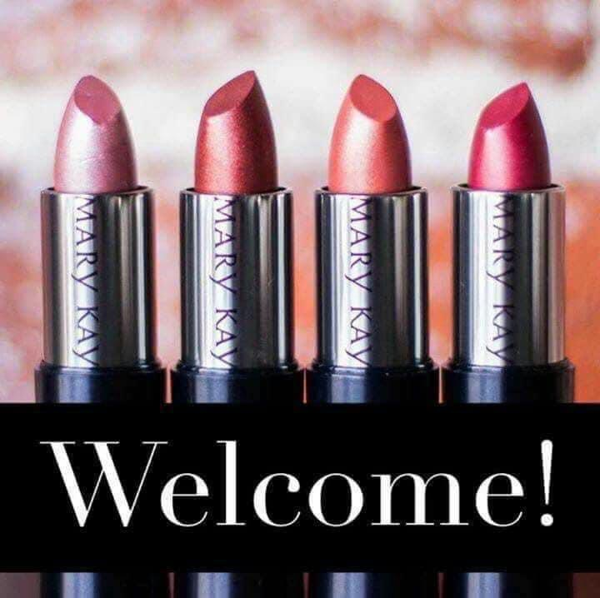

Lead up post #2:

Great morning, beauties! ☀️

💋 Let’s do a ROLL CALL with a twist! Introduce yourself “like a boss” & tell me how YOU know Ash Moore, our hostess with the mostest?!? 🥰

I’m Lindsay & I made my bed like a BOSS! 😂 I know Ash because she attended a virtual beauty experience just like this one last week & decided to host her own party!! 🎉

🎟🎟🎟 Comment below for 3 tickets into a prize drawing on the FB Live Party on 6/5 at 6pm! 🎟🎟🎟

Please make sure to PM me your address if you haven’t already so I can send you a pampering package full of samples to try during the FB live pampering session in a couple weeks!! 💖
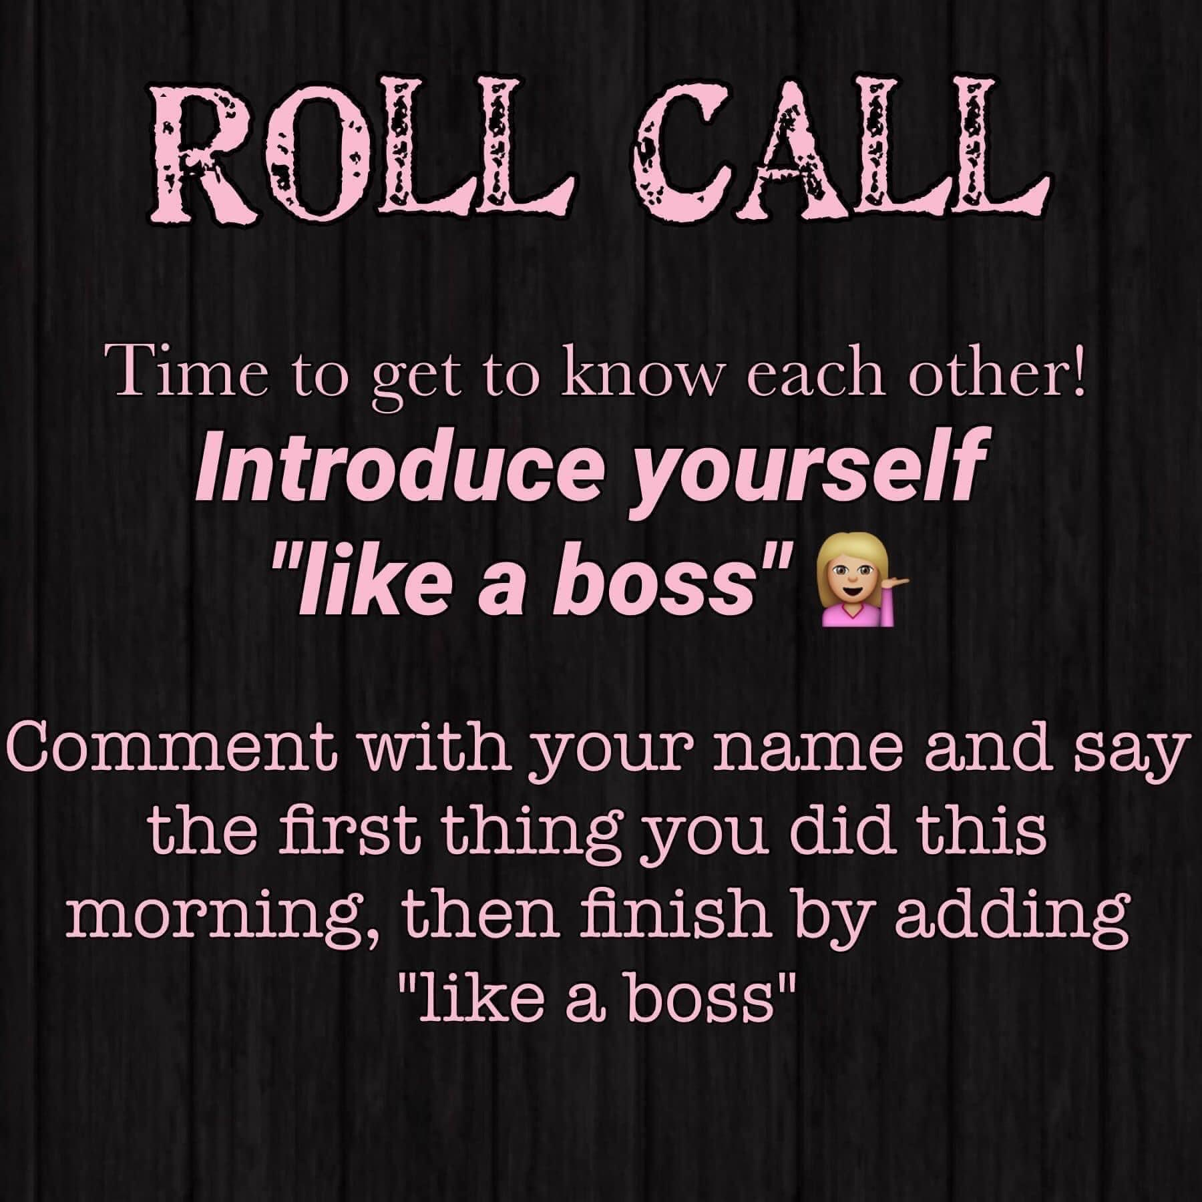

Lead up post #3:

Check-in daily for any post with a 🎟

These posts will get you entered into a prize drawing for a FREE PRODUCT GIVEAWAY at our party! 🤩🎟🤩🎟🤩🎟🤩

Go into settings and turn ON the Notifications!!
Hit the 3 dots (or 3 lines) in the upper right-hand corner. Go to notifications and hit All Posts! 🙂

Comment “done” after turning on your notifications to earn 5 entries
🎟 🎟 🎟 🎟 🎟
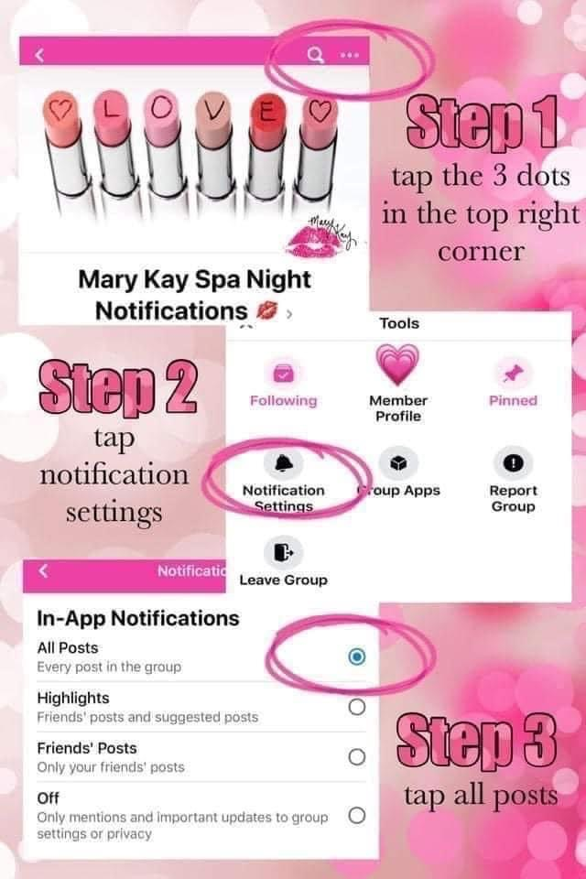

Lead up post #4:

I am TOO excited for Ash Moore’s virtual spa party next Sunday! 🥳

How this works is I’ll mail you FREE samples & we’ll all get to pamper ourselves from the comfort of our own homes right here on a Facebook Live party together! 🧖‍♀️

SHOUT OUT to these fabulous ladies who have already sent me their addresses to get their pampering package for the spa day!
(Tag guests who have sent you their addresses here)

(Tag all members of the group who haven’t given you their address yet here) ~ please make sure to PM me your address so I can mail you a pampering package full of FREE samples for the FB Live party Sunday 6/5 at 6pm! 😍
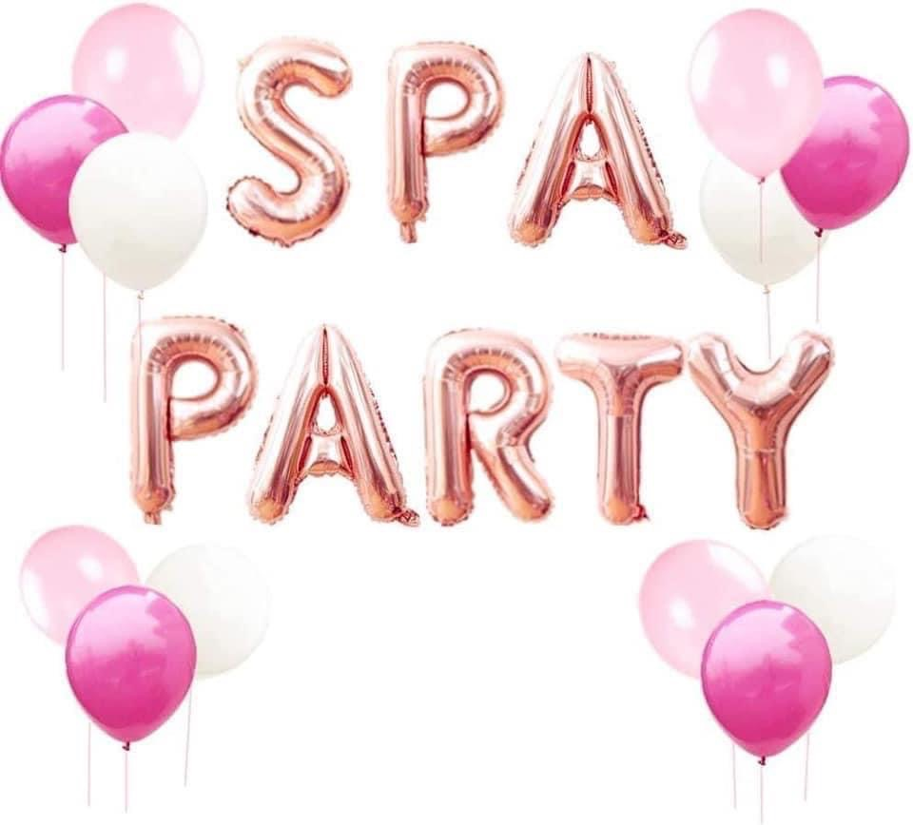

Lead up post #5:

Did you know⁉️

Mary Kay stands behind its products 100% when sold by Mary Kay Independent Beauty Consultants! (aka me 😉)

So that means that if for ANY reason you are not completely satisfied with any product purchased it will be replaced without charge, exchanged or refunded. No need to worry about being “stuck” with something if the shade isn’t what you were thinking or the product didn’t work your skin with this policy, so shop away! It’s all good!

🎟 PRIZE ENTRY 🎟
What’s the worst purchasing mistake you’ve ever made?! Drop it in the comments 👇

(Mine was definitely a foundation that turned me ORANGE! I looked like an Oompa Loompa! 😆😂)
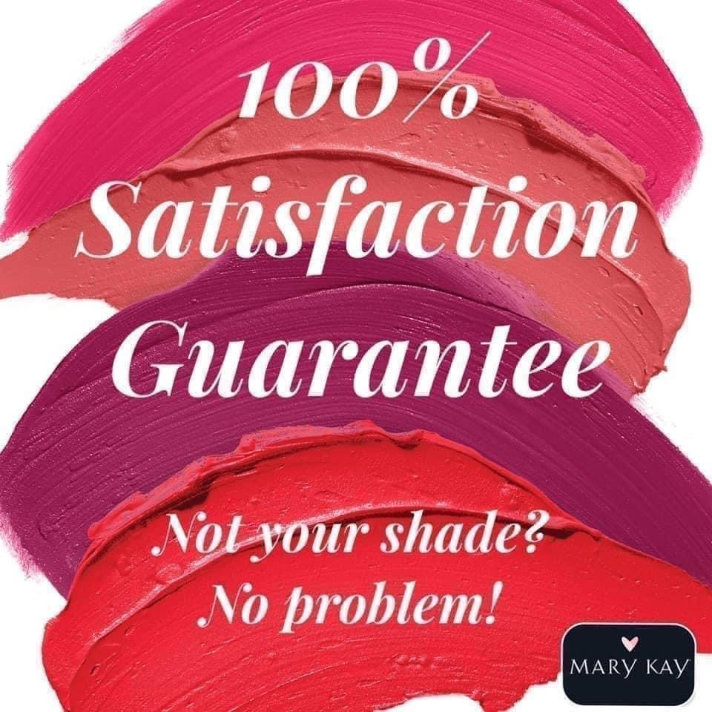

Lead up post #6:

For a 🎟 PRIZE ENTRY 🎟…comment with the one beauty item you can't live without!!💄

Mine is MASCARA, hands down! If I put nothing else on my face, it’s mascara for sure! I feel like it wakes up your whole face! 😍🥰
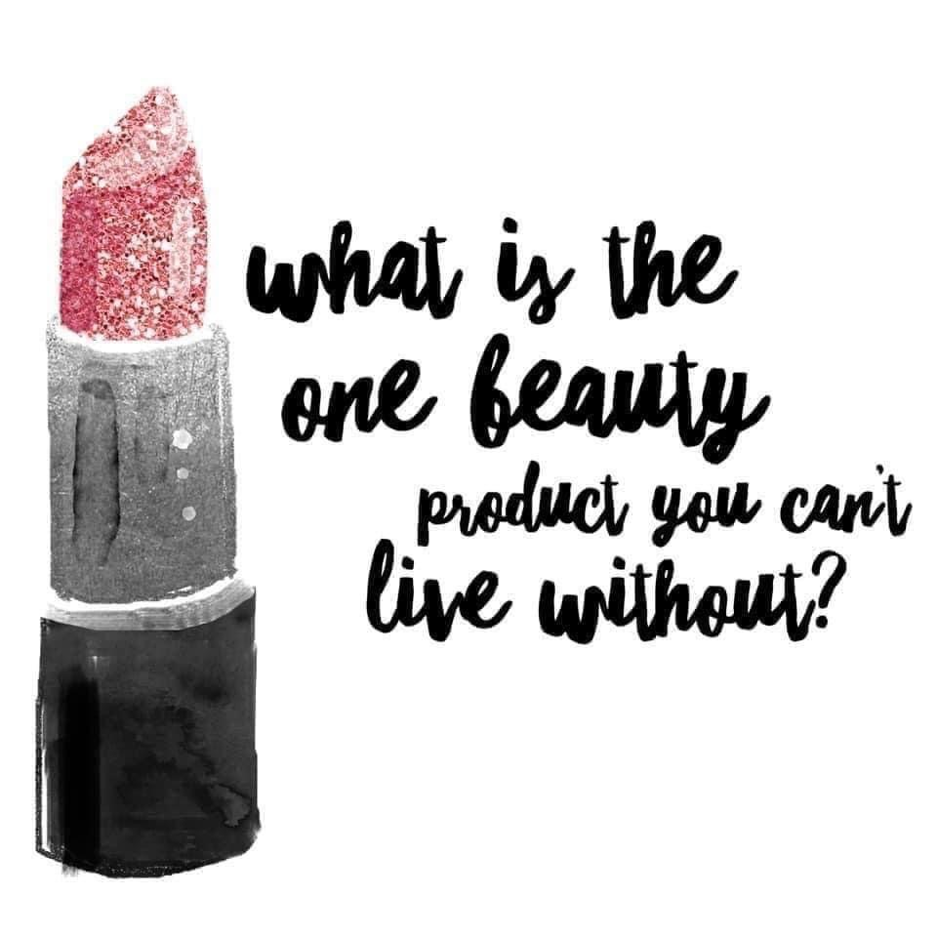

Lead up post #7:

This is ALWAYS a fun way to get to know each other a little better…

My answer is most definitely SHOES!!! I may or may not have an addiction to buying them 🥴😆😂

What’s yours?! For a 🎟… drop your answer in the comments! 🎟
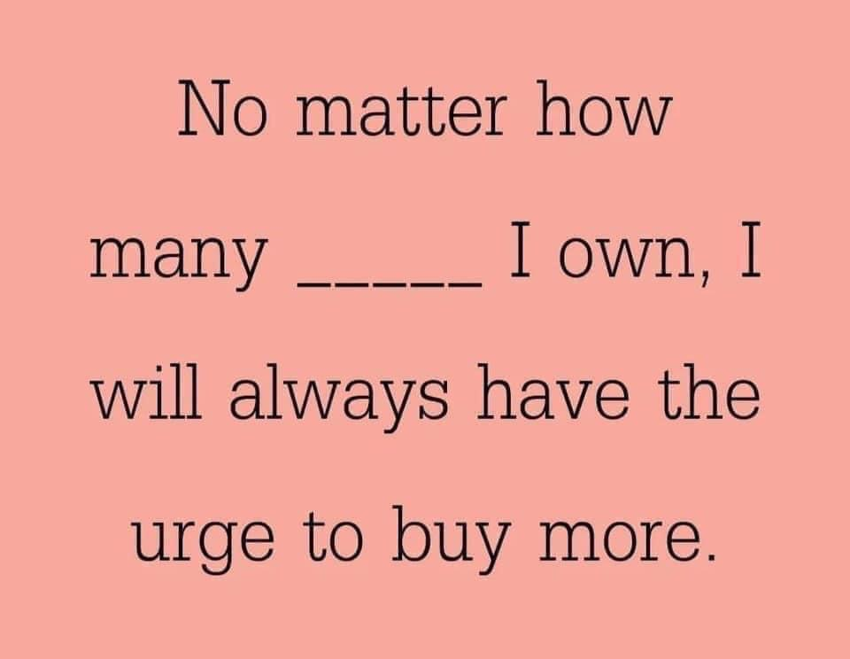

Lead up post #8:

Here at Mary Kay, we are obsessed with great skincare! 🧖‍♀️

I’m a firm believer that your makeup will never be a 🔟 if your skin care is a 2️⃣!!! 🙌

At our virtual beauty experience next Sunday, you will be trying our #1 best-selling skin care line — the Timewise Miracle 3D Skin care Set!

It’s suitable for sensitive skin & even skin types with rosacea! 🙌 and the best part?! It’s age-defying!!!! 😍😍😍 here’s a short clip that tells you ALL about it! https://m.youtube.com/watch?v=O_vVJhn_XYw

For a 🎟 PRIZE ENTRY 🎟 … tell me in the comments, what is ONE skin care concern you have?
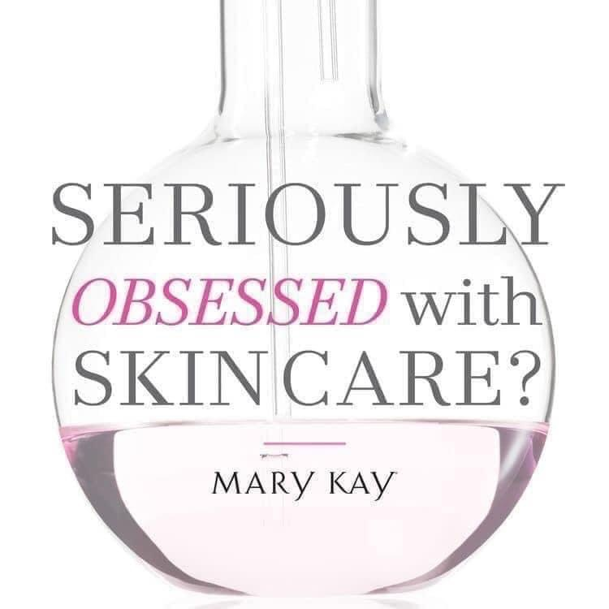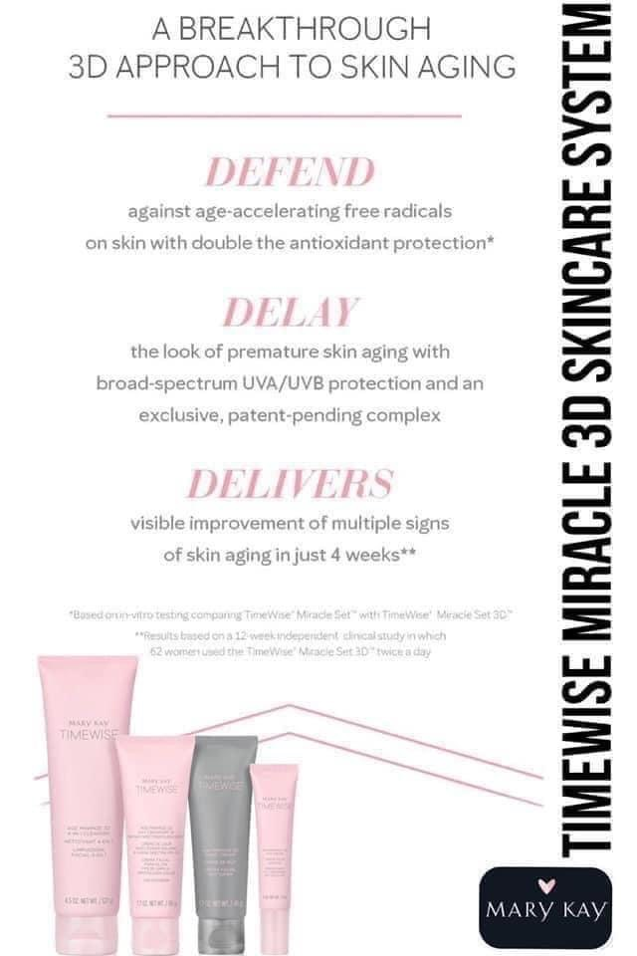

Lead up post #9:

Are you a skin care girl 🧖‍♀️ or a glamour girl💋?

🎟 Comment “THIS” or “THAT” for an entry into our prize drawing! 🎟

I’m a totally “THIS” girl EVERY DAY & a “THAT” girl when I’m feeling extra! 😉
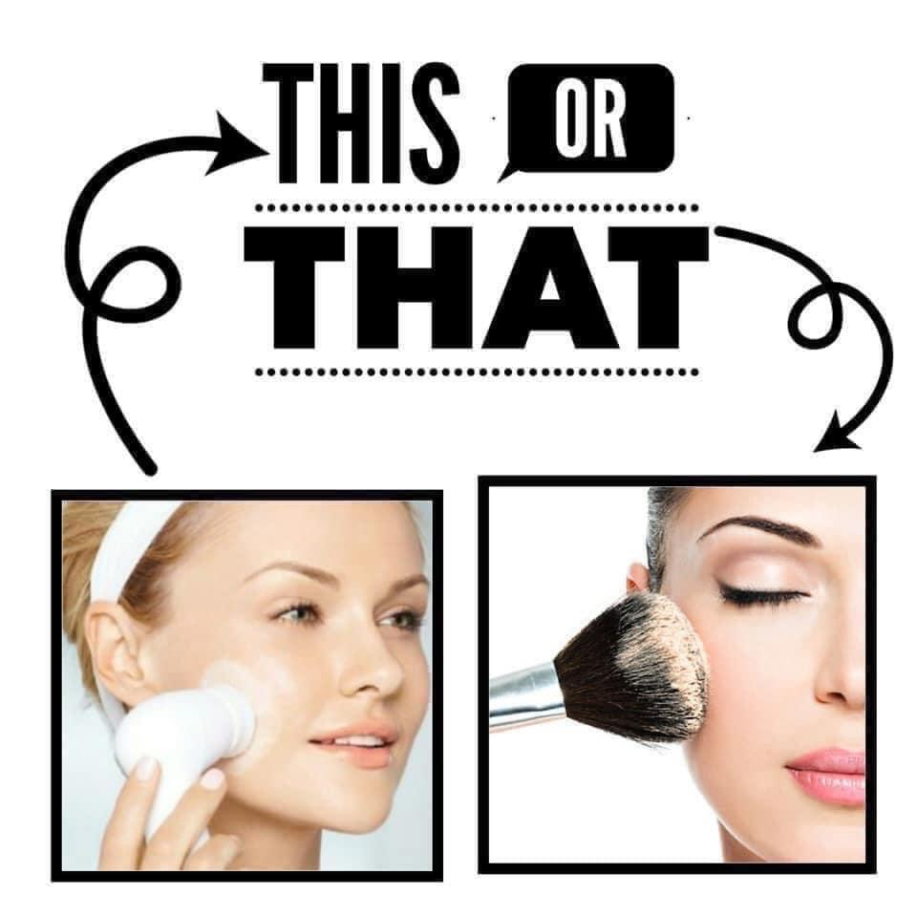

Lead up post #10:

Allow me to introduce you to one of my all-time favorite products!

DEEP. WRINKLE. FILLER. 😱

I am obsessed! 😍😍😍 it’s like spackle for your face!!! The retinol plumps up the wrinkle to fill it in instantly right before your eyes but also helps fill them in permanently over time as well!!! 🙌

It’s a targeted wrinkle product so you just put this specifically where you need it, not your whole face. This is very beneficial even to young women who may just have one forehead wrinkle.

For a 🎟 PRIZE ENTRY 🎟 tell me, on a scale of 1-10…how deep are your wrinkles?
1 = what wrinkles?!
10 = deeper than the ocean, girl!
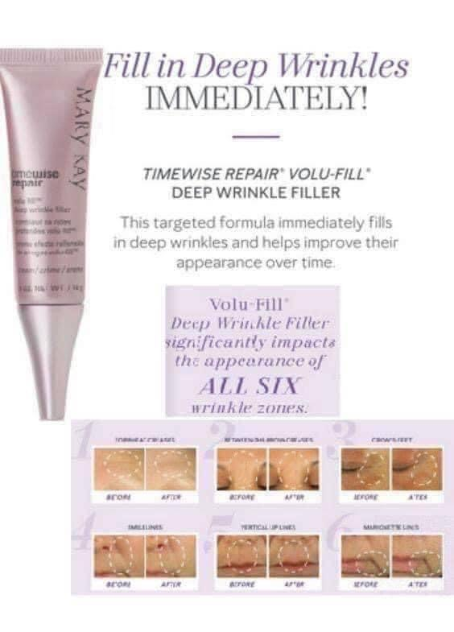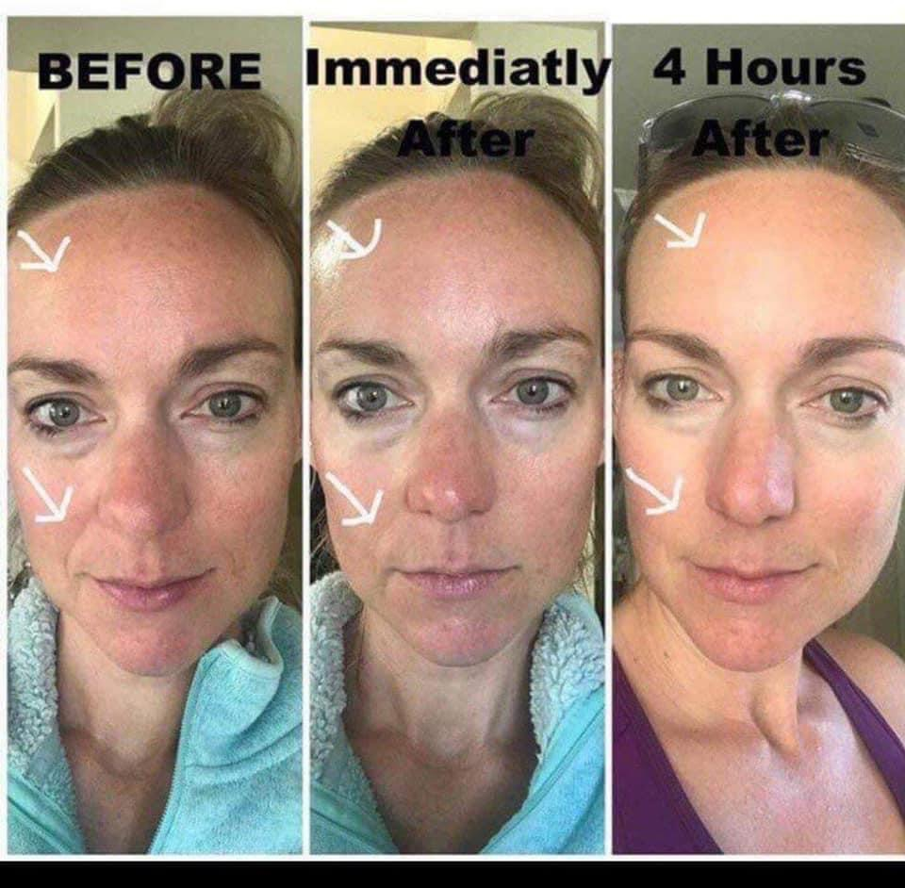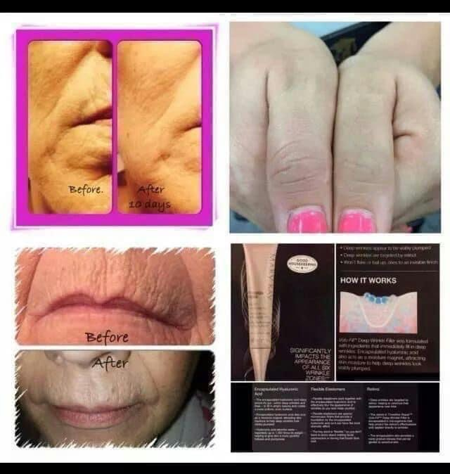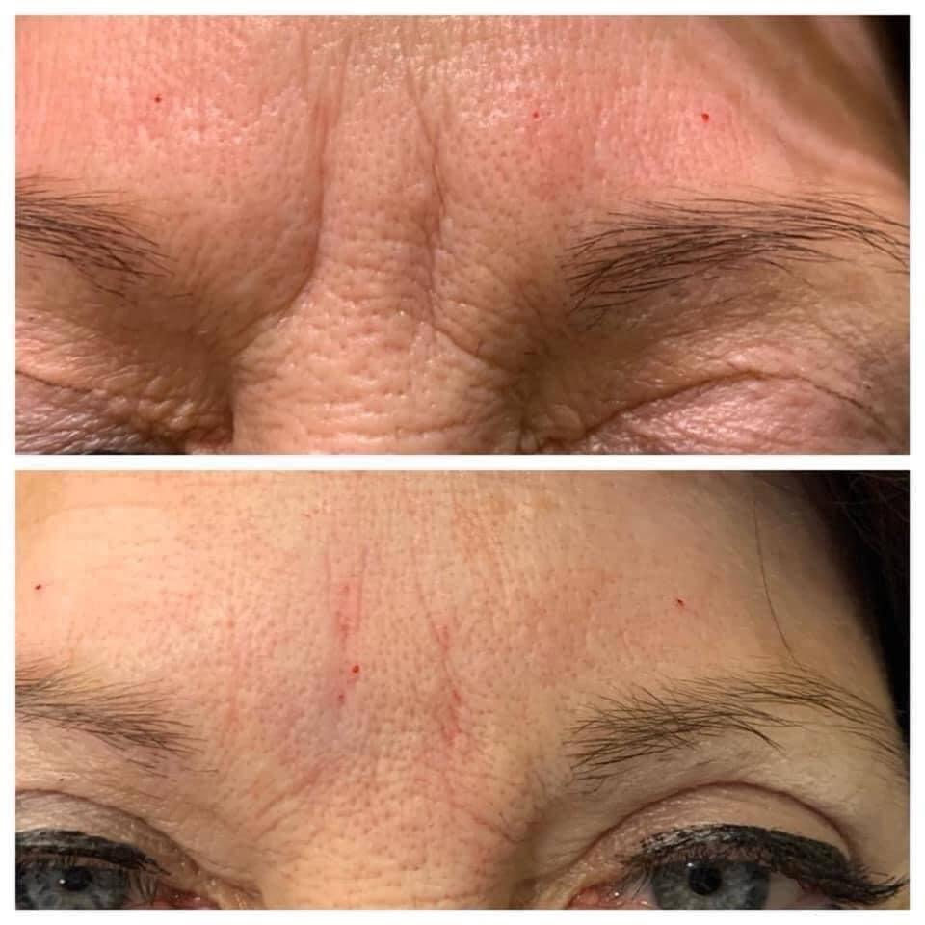

Lead up post #11:

Happy (day of the week), beauties!

For a 🎟 PRIZE ENTRY 🎟…

Post the last inspirational quote saved in your phone in the comments! 👇

I shared mine in the post! 🙌
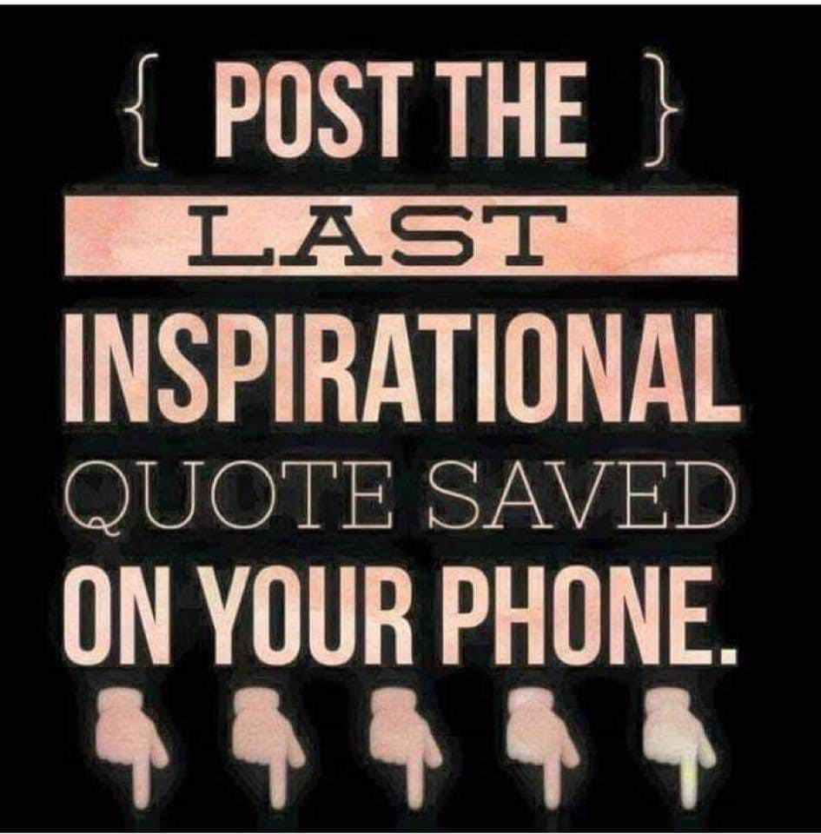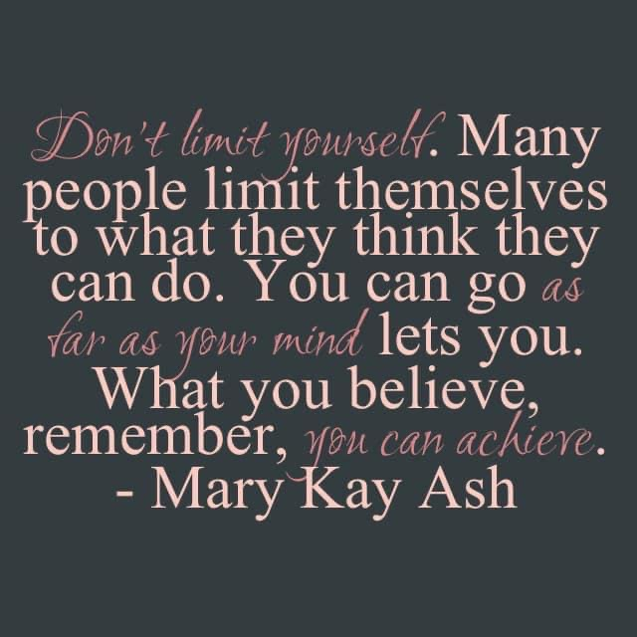

Lead up post #12:

🎟🎟 PRIZE ENTRY! 🎟🎟

Which would you choose? Fragrance-Free or White Tea & Citrus?

A Mary Kay fan favorite ~ the Satin Hands Pampering Set!!! PERFECT for soothing dry hands, especially with colder months approaching! 🙌

This three-step, spa-like treatment revitalizes and rejuvenates the look of hands, so they feel renewed and instantly look healthier.

Instantly, hands feel moisturized, soft and smooth.
•Satin Hands® Satin Smoothie®
•Refining Shea Scrub
•Satin Hands® Nourishing Shea Cream pamper hands with shea butter.

PRO TIP 💡
Use it on your feet in between pedicures to keep your feet nice & smooth too! 🙌 you’re welcome! 😉
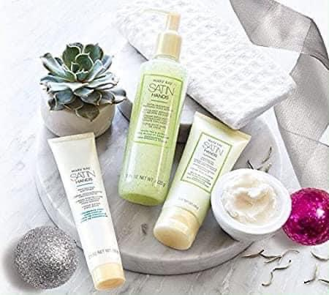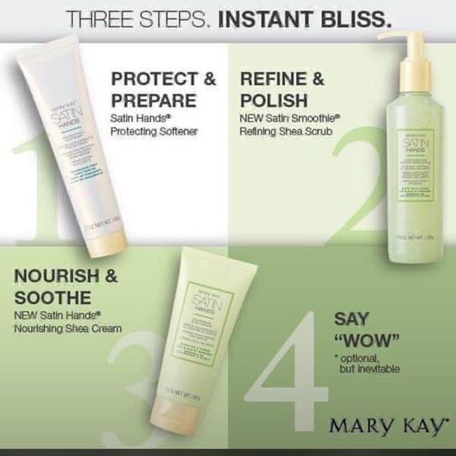

Lead up post #13: (Sunday specific — edit this to be relevant to YOU!)

Sunday check-in!!! ♥️

For a 🎟 PRIZE ENTRY 🎟…tell us something you enjoyed doing last week!

I got to spend the day with my family in my hometown yesterday & today we’re spending the day at my aunts house with 4-wheelers, a huge pond, yummy food & cold drinks! 😁 Quality time with my favorite people makes my heart happy! 🥰
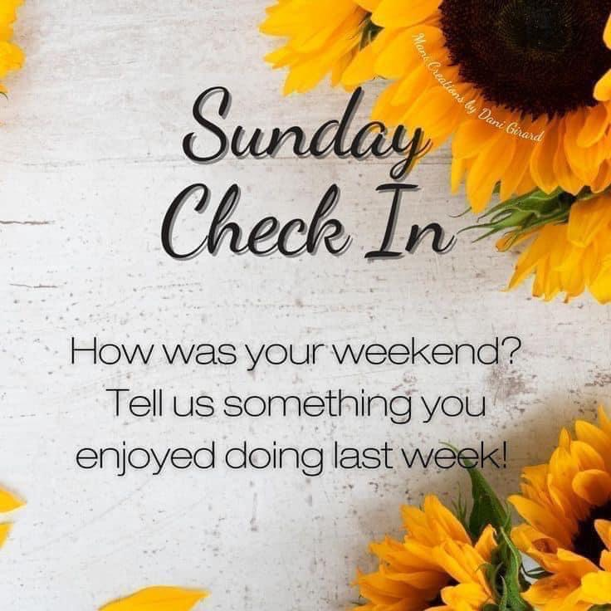

Lead up post #14:

Ready to make a pow(d)er move? 💪 With NEW! Mary Kay Silky Setting Powder, you can choose from 12 natural-looking shades designed to match your skin tone seamlessly and create a soft-focus, mattifying effect. Pairs perfectly with your favorite foundation!

🎟🎟 PRIZE ENTRY 🎟🎟
Post your favorite girl power emoji or gif in the comments 👊
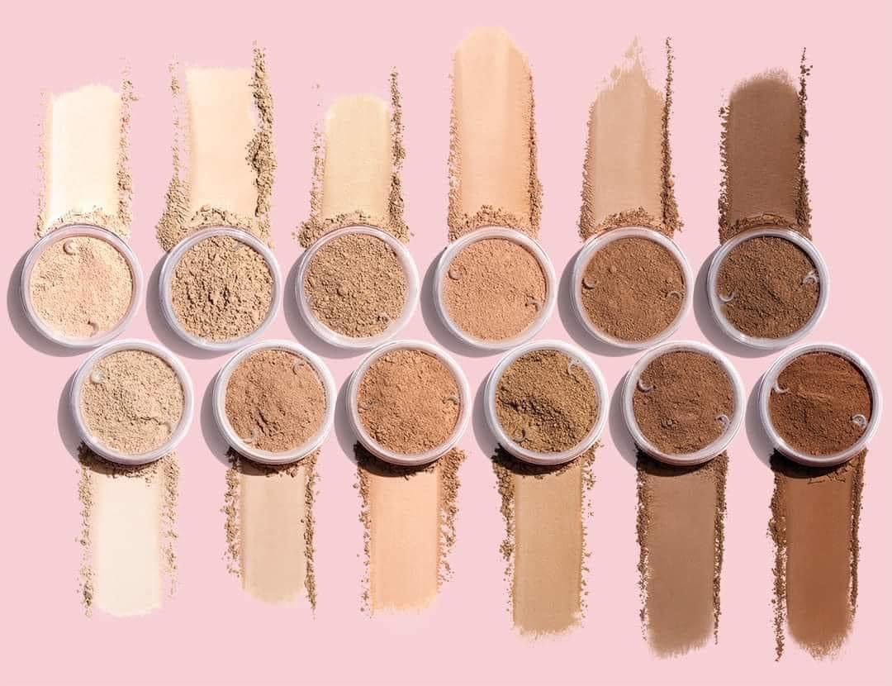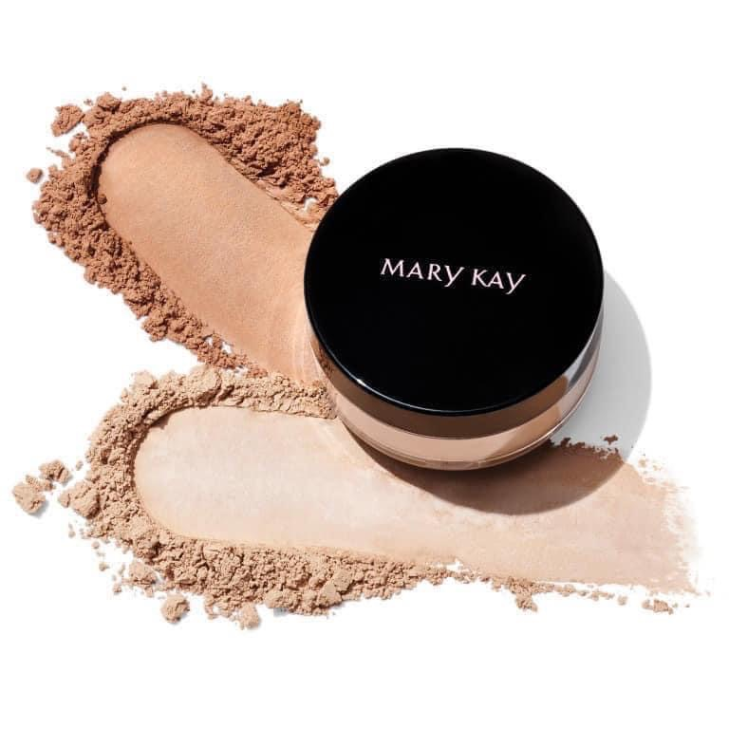

Lead up post #15: (Monday specific)

Great morning, beauties! ☀️

Monday morning definitely calls for coffee! ☕️ (but who am I kidding?! I start EVERY day with coffee!! 😂🤣)

🎟 PRIZE ENTRY 🎟
I gotta know…are you an iced or hot coffee lover? Drop your answer in the comments 👇 bonus entries if you use a GIF! 😉
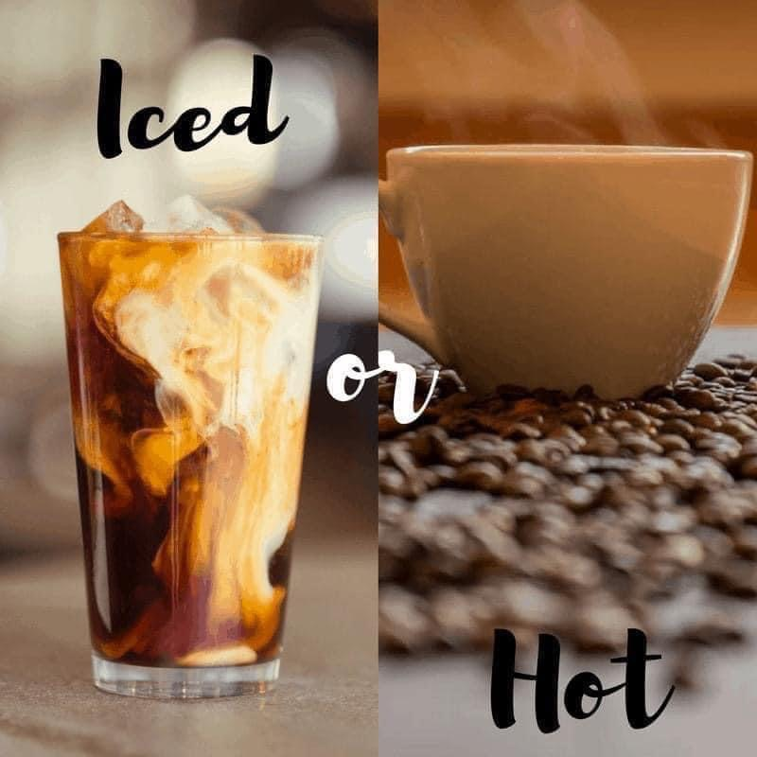

Lead up post #16:

Where are my mascara lovers?! 😍🙋‍♀️

My ALL TIME FAVORITE Lash Love Fanorama Mascara is officially now a REGULAR LINE mascara & ready to be a part of your mascara wardrobe! 🎉

This FAN-favorite formula contains Mary Kay Panthenol-Pro Complex and vitamin E to help moisturize, strengthen and condition lashes. Plus, it helps bring even your littlest lashes out of hiding with the innovative brush!!!

🎟🎟 PRIZE ENTRY🎟🎟

Comment below with what YOU look for in a mascara? Length, volume, definition? ALL OF THE ABOVE?!? 😍😍😍
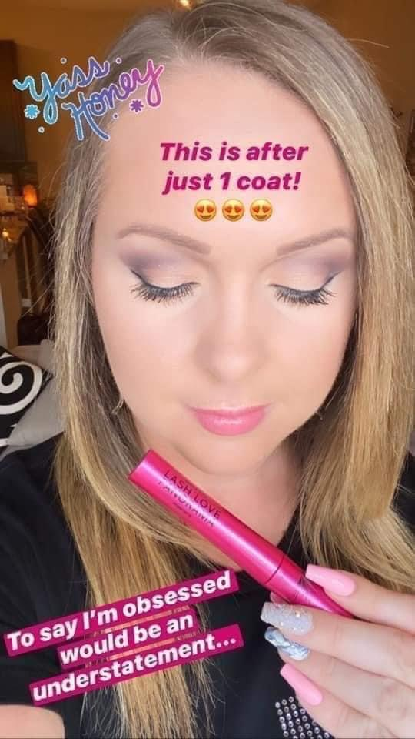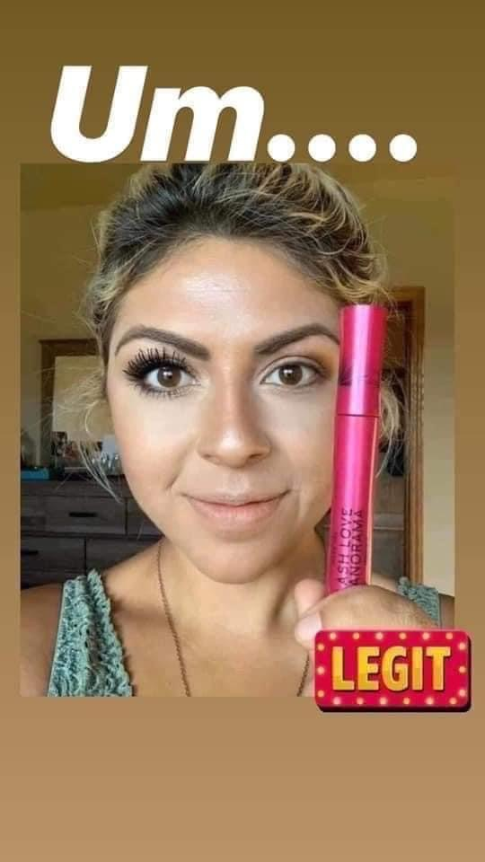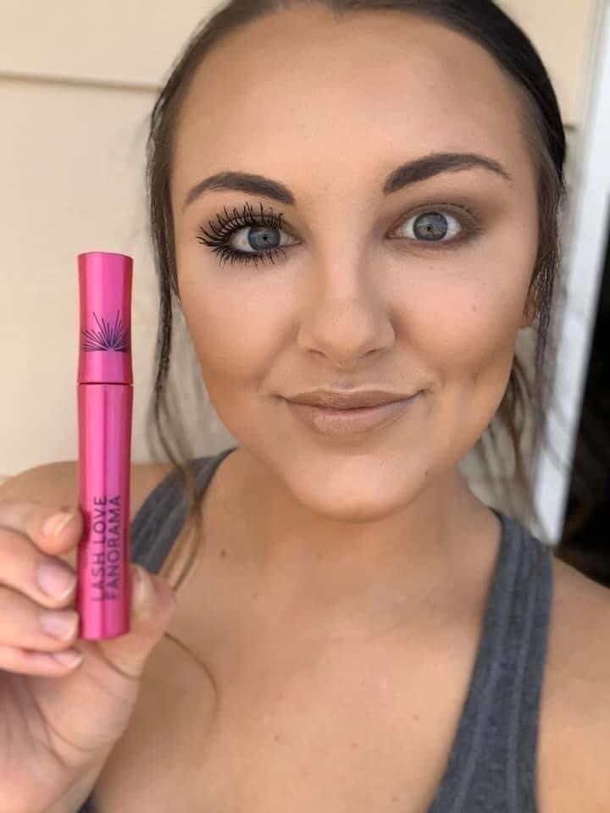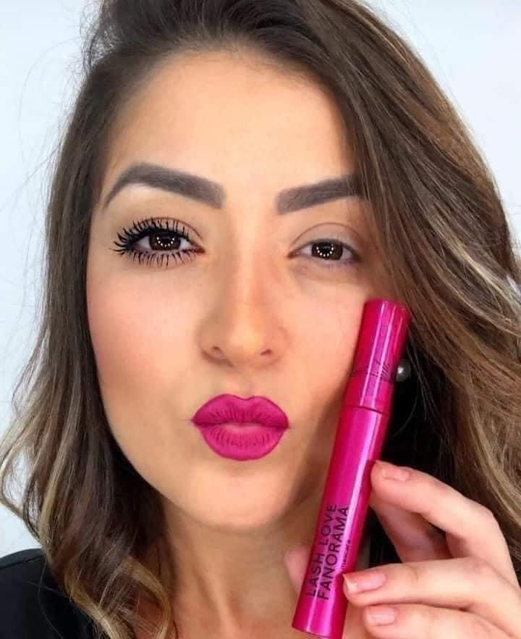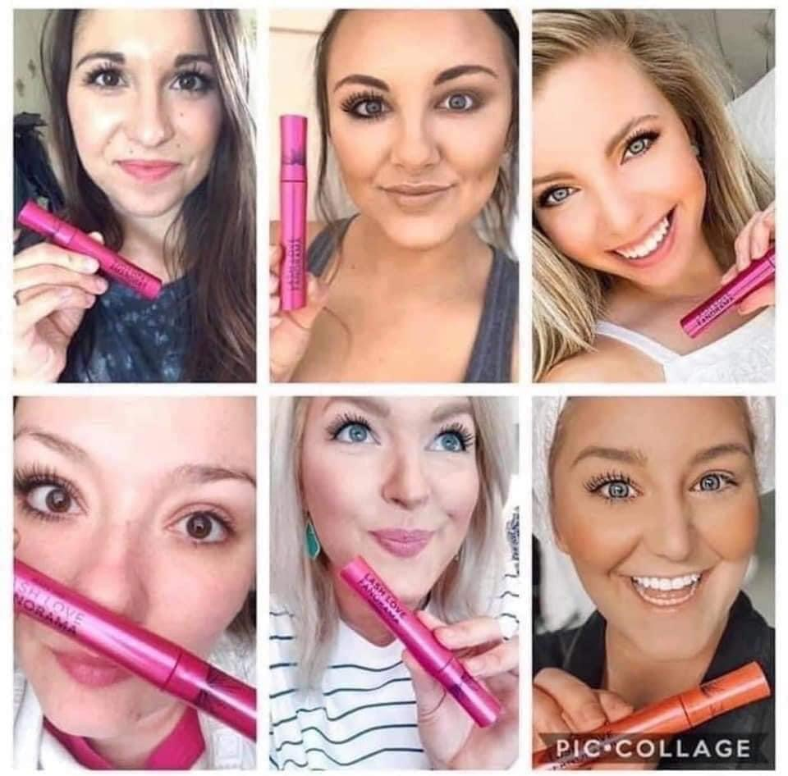

Lead up post #17:

Let’s hear it!!! 👂

For a 🎟🎟 PRIZE ENTRY 🎟🎟 …

Finish this sentence! 👇

Lead up post #18:

Say HELLO to one of my all-time FAVORITE PRODUCTS ~ Botox in a Bottle! 😍😍😍

Aka the TimeWise Repair Revealing Radiance Facial Peel! Every woman needs this in her life!!!! 🙌

In a clinical study, the Revealing Radiance® Facial Peel was shown to have these benefits:
** Skin looks brighter.
** Skin texture is significantly improved.
** Fine lines and wrinkles look reduced.
** Skin tone looks more even.
** In addition, women saw these
immediate benefits after use — skin that looked more radiant and felt smoother and tighter.

So HOW does it work?! 👇
1️⃣ The glycolic acid goes to work immediately, removing dead skin cells from skin’s top surface layer.
2️⃣ This exfoliating ingredient also works on the remaining surface layers, breaking apart the bonds connecting thousands of other dead cells so they can be released and plumper, fresher cells can take their place. By increasing the rate at which skin-dulling dead cells on multiple surface layers are eliminated, the power of glycolic acid enhances skin’s own renewal process for a rejuvenated look.
3️⃣ This advanced exfoliation method also significantly smooths skin, reducing the “hills and valleys” associated with a drier rougher texture.
4️⃣ Once the layers of dead surface cells have been removed, your skin will be primed and ready to accept the benefits of other age-fighting treatments.
⭐️ BONUS — Because we wanted the formula to be gentle enough to use twice a week, we paired the glycolic acid with an exclusive blend of calming botanical extracts. And since some people can experience dryness after using a peel, the formula also contains a marine extract which has been shown to have hydrating benefits.

For a 🎟 PRIZE ENTRY 🎟 -- tell me, have you ever been to a spa for a professional facial? 🧖‍♀️
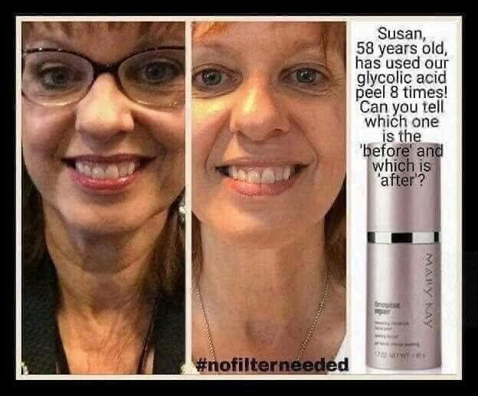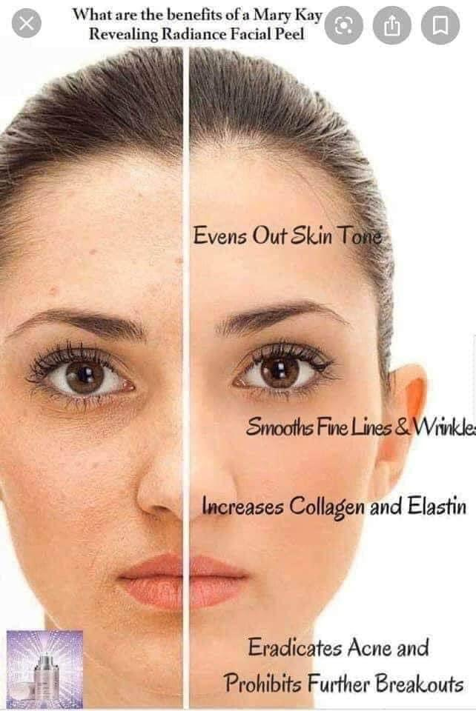

Lead up post #19:

For a 🎟🎟PRIZE ENTRY🎟🎟 … tell me what you would do if you had an extra 20 minutes of peace and quiet?! 💕
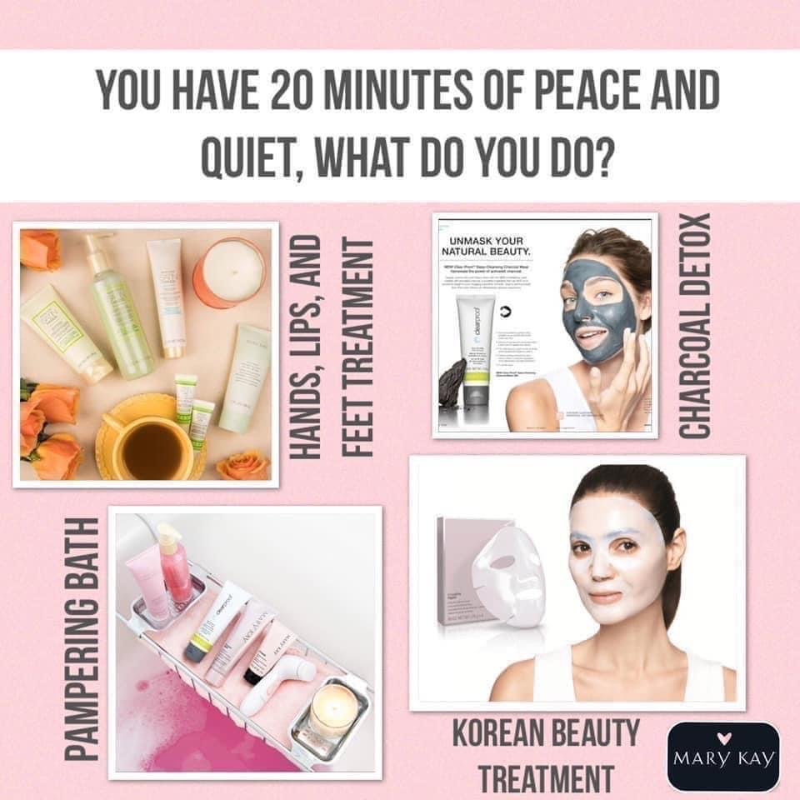

Lead up post #20:

📢 This just in! 📢

Mary Kay just launched a NEW! line of lipsticks & they are SO JUICY GOOD! 💄

Meet your new BFF ~ Supreme Hydrating Lipsticks 😍😍😍

💰Rich color. 🌟 Brilliant shine. NEW! Mary Kay Supreme Hydrating Lipstick nourishes lips with sunflower oil and vitamin E in 8 gorgeous shades. 💋

🎟 PRIZE ENTRY 🎟
Which color is your favorite?! 💄

https://www.youtube.com/watch?v=yLOGPZ8uYNA
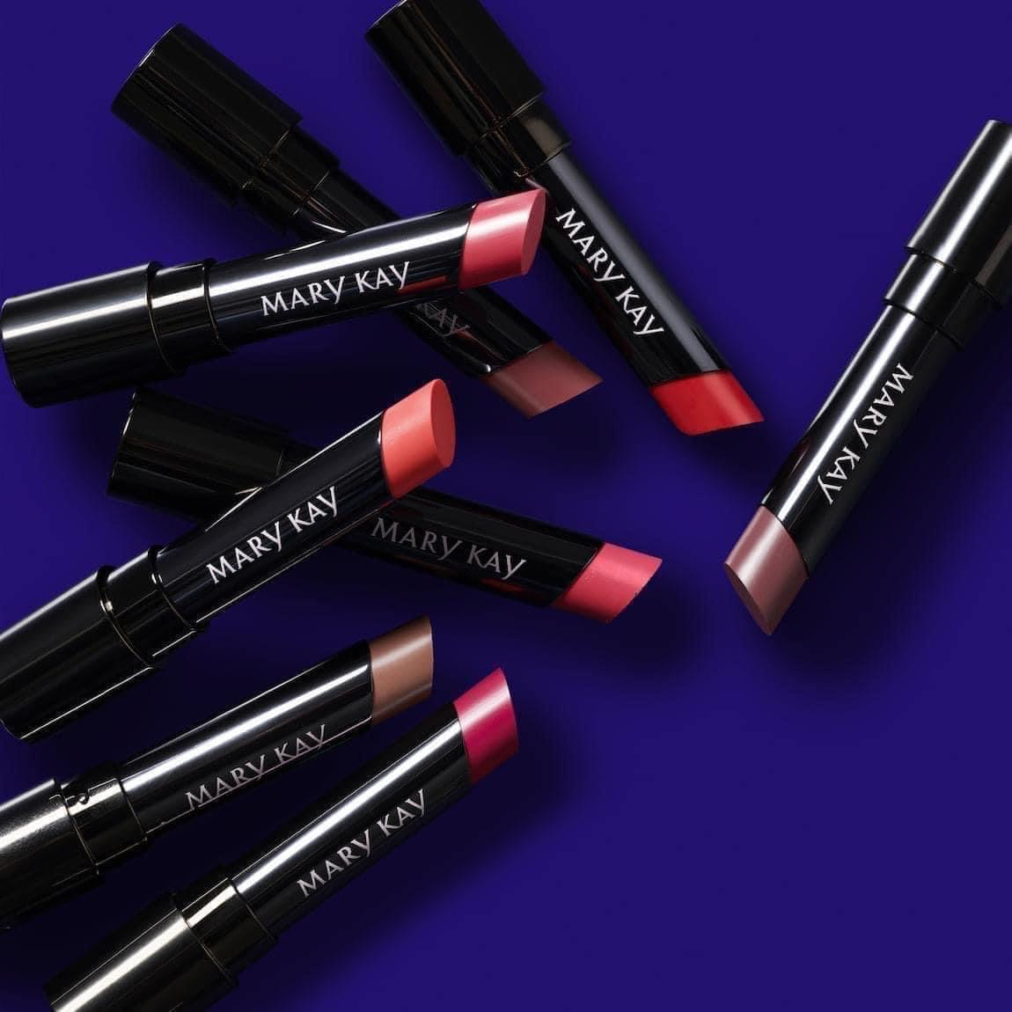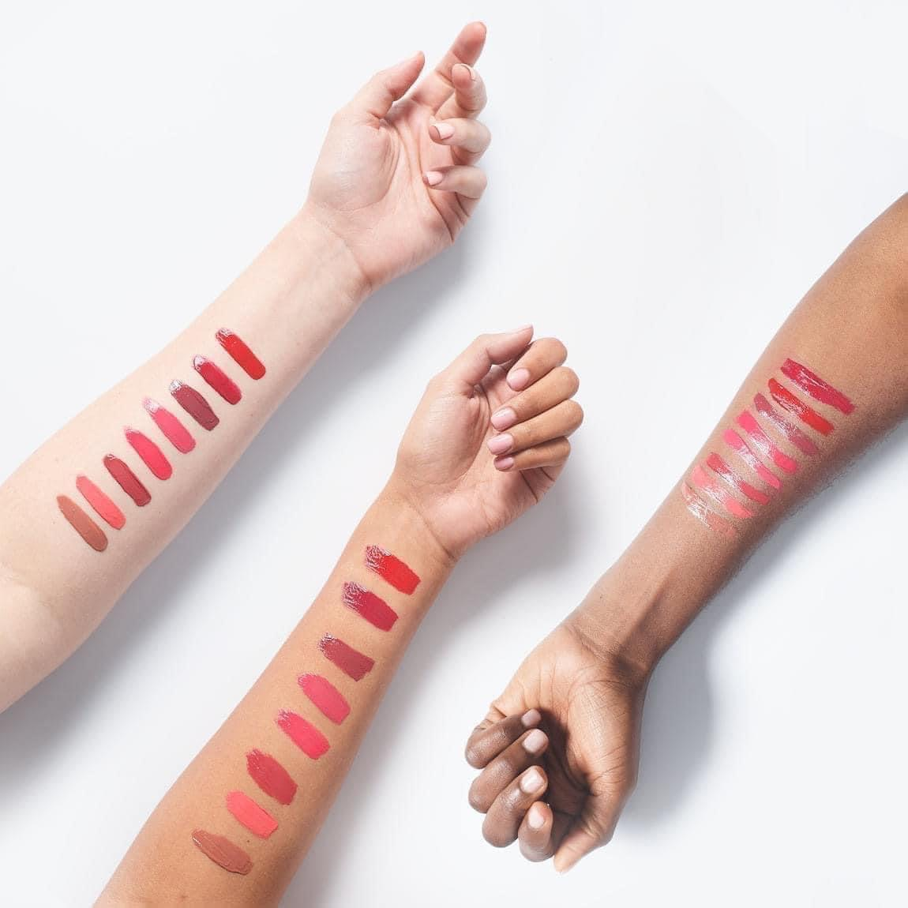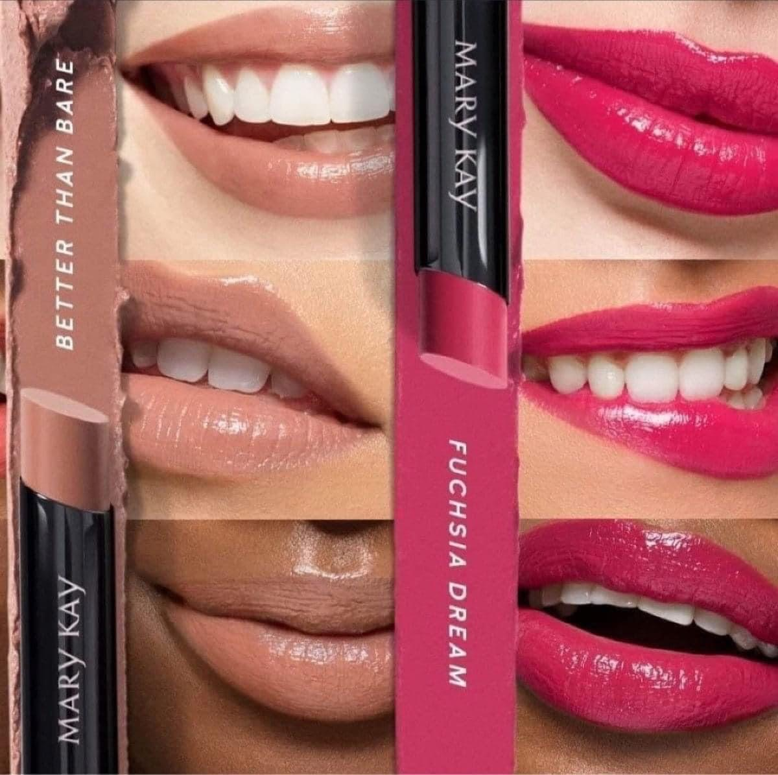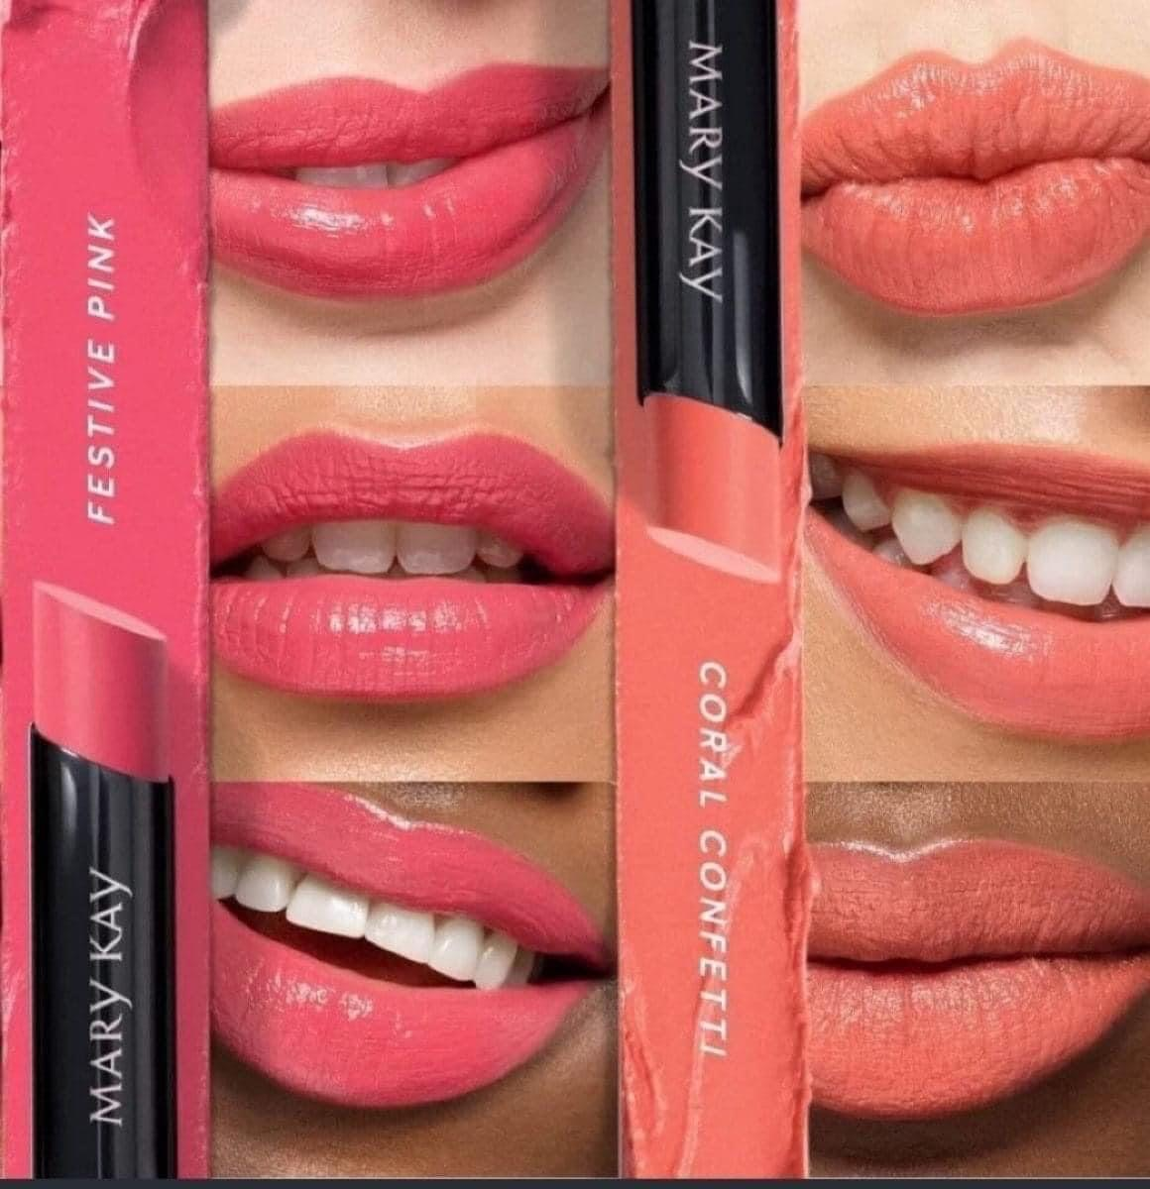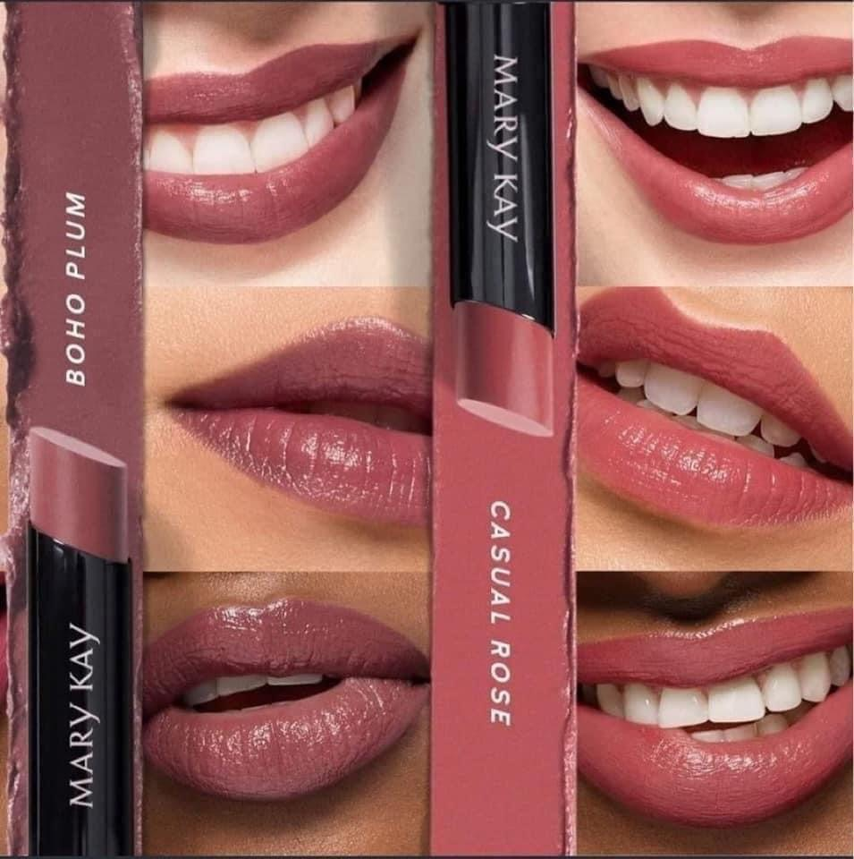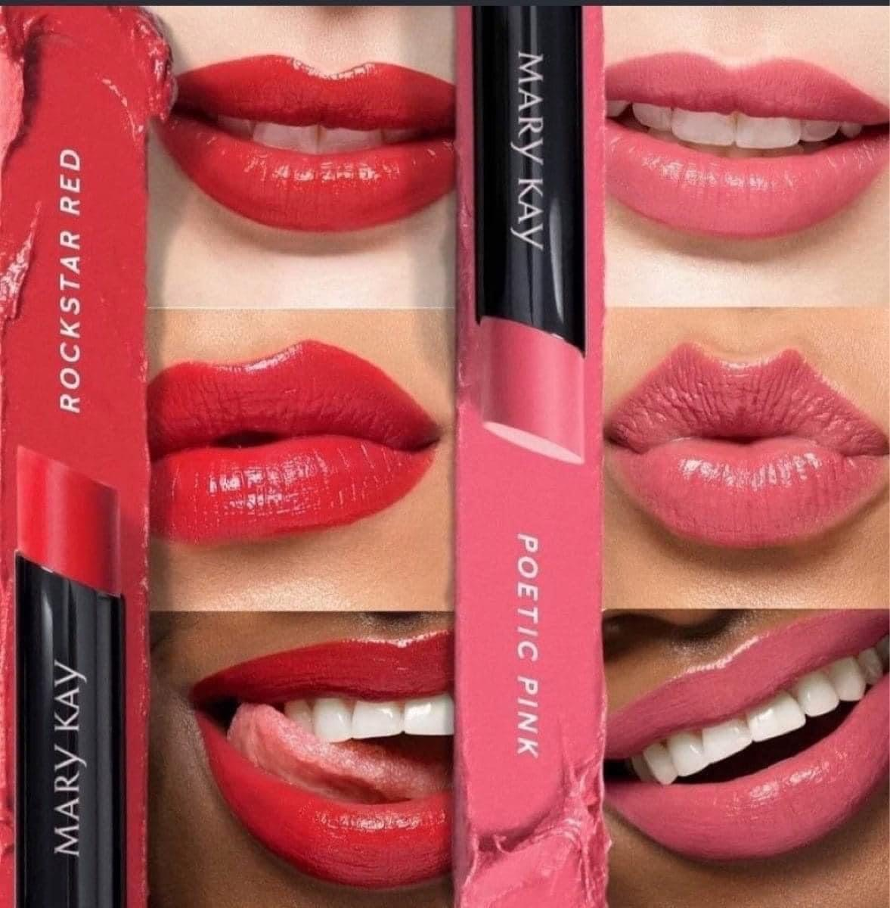

Lead up post #21: (Thursday specific)

“Acknowledging the good that you already have in your life is the foundation for all abundance.”
—Eckhart Tolle

I am a firm believer that there is ALWAYS something to be thankful for! 🙌

For a 🎟🎟 PRIZE ENTRY 🎟🎟 … I would love to hear what YOU’RE thankful for today! 🥰

I am thankful for SO many things, so I’ll just name a few — my faith, my family, my friends & a career I LOVE that allows me to operate in my God-given gifts & talents! 💖
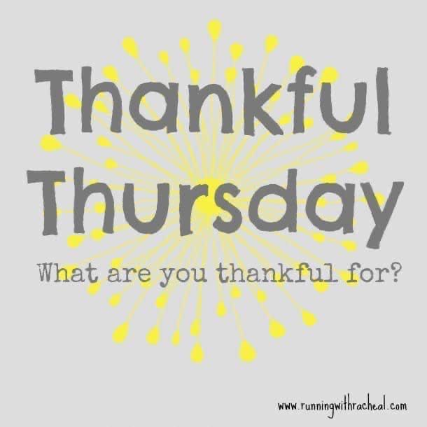

Lead up post #22:

🆓 FREEBIE TIME! 🆓

📲 Download the Mary Kay Skin Analyzer App and send me your results via messenger to earn a $5 gift card to use at Ash’s spa night Sunday!

🎟🎟🎟🎟🎟 AND get 5 BONUS entries into our FREE PRODUCT GIVEAWAY when you do! 🙌
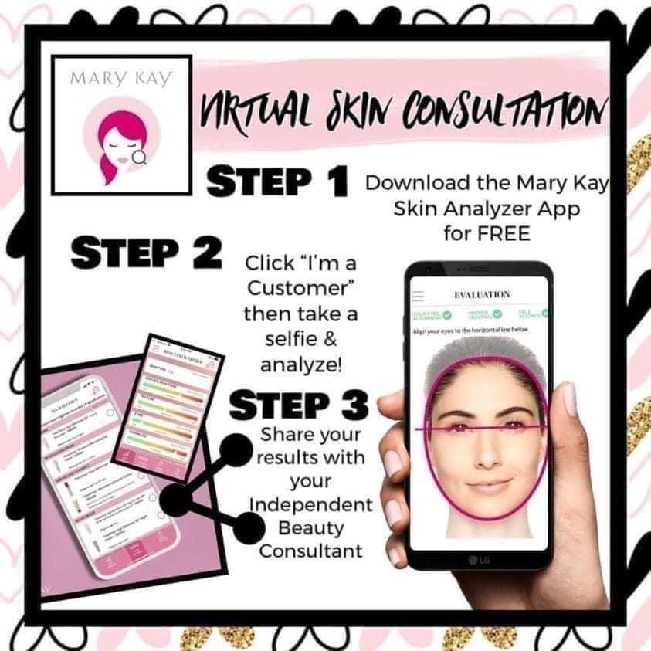

Lead up post #23: (Friday specific)

Happy Friday, friends!!! YOU MADE IT TO FRIDAY!!! 😍🥰

For a 🎟🎟 PRIZE ENTRY 🎟🎟 — what would YOU tell your 18-year-old self?!

Oh man, there are SOOOOOO many things I wish I could tell my 18-year-old self…but if I had to choose, I think I would say…

“TRUST YOUR GUT!” 💯
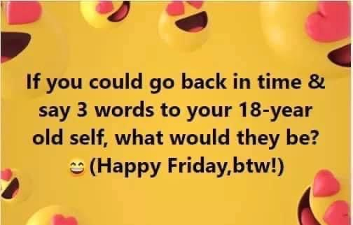

Lead up post #24:

Anyone else ever struggle with undereye puffiness & designer bags? ESPECIALLY after a long week?!? 🥴

Pack Your Bags ladies!

Pack. Your. Bags.

Undereye Bags that is! 😉

Mary Kay's hydrogel patches are AMAZING!

Here’s how they work:

Step 1: Put them under your eyes (you can also use them other areas as well, like smile lines, forehead, etc)

Step 2: Wait 20 minutes 🕒

Step 3: Remove them and lose your mind 🧠 at how good you look!!

And there are 30 pairs in a jar!!!🙌🏻🤩

❌ Goodbye fine lines & wrinkles

❌ Goodbye puffiness

❌ Goodbye under-eye circles

❌ Goodbye Bags!

✔️ Hello lift

✔️ Hello moisture

✔️ Hello smooth

✔️ Hellooooo brighter skin

Comment below for a 🎟 PRIZE ENTRY 🎟 if you would like to try these 👇
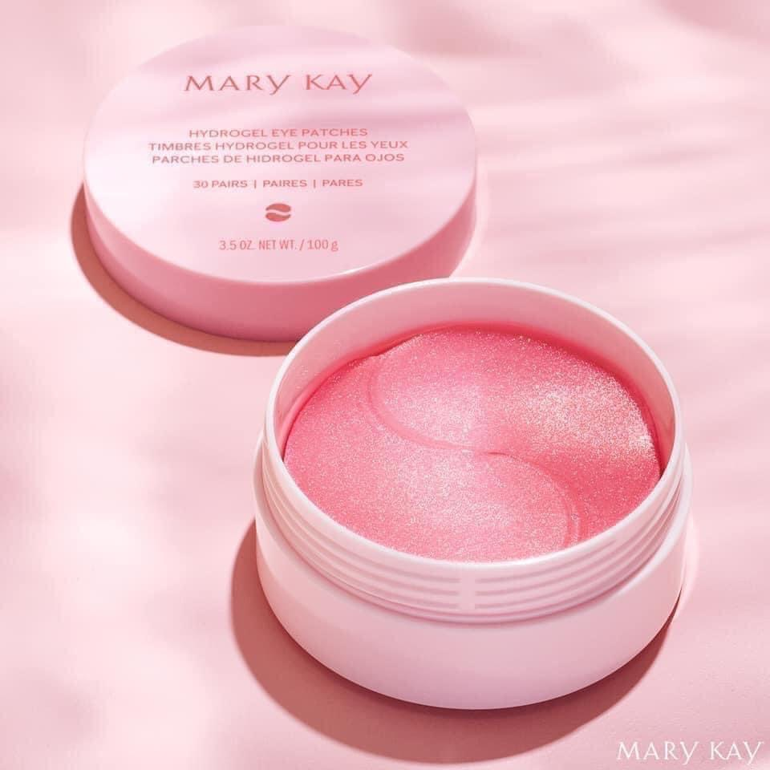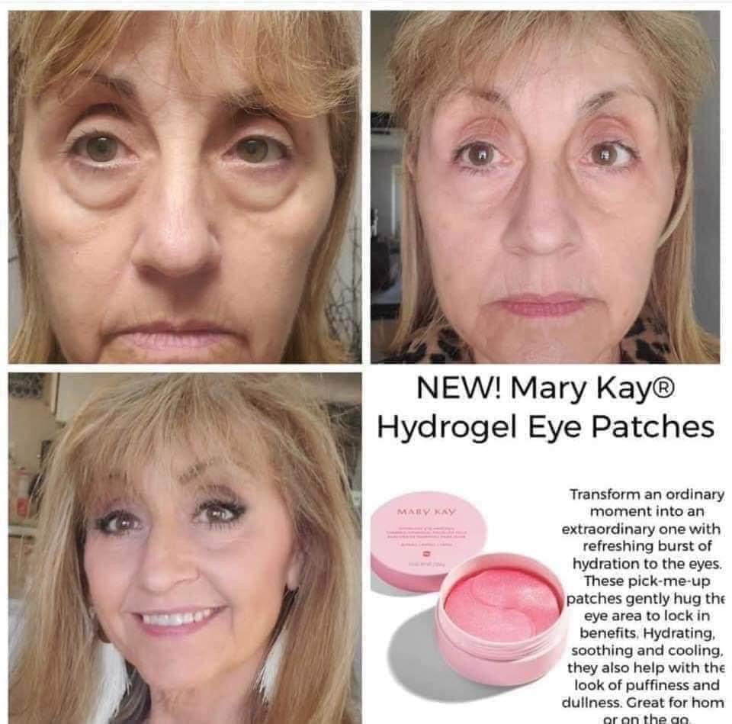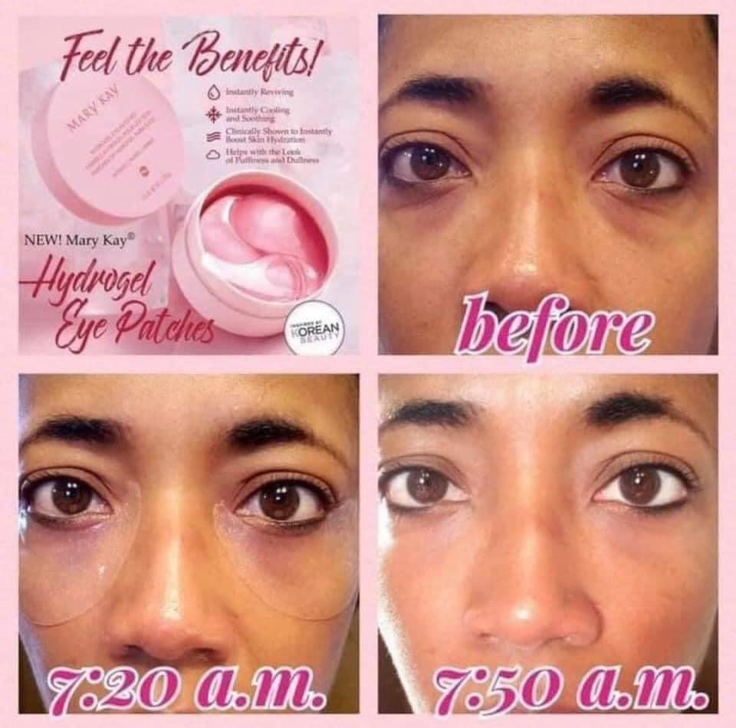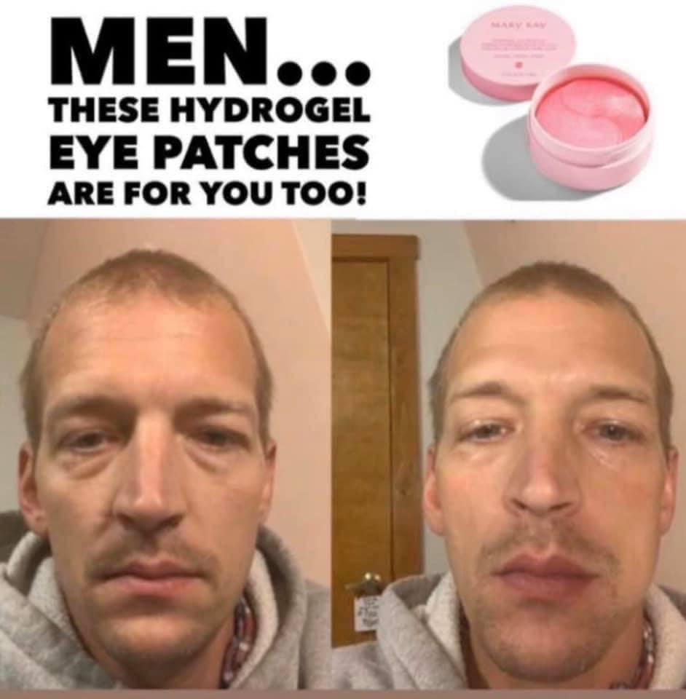

Lead up post #25: (day before the party)

Get ExCiTeD! Only ONE DAY til our spa party!!! 😍🥳🎉

I am BEYOND grateful to be a part of an amazing team of ladies! 🙌 this business has blessed my life in SO many ways & I’m SO GLAD I said “YES!” to all of the pink possibilities MK has to offer! 💖

Let's play a game that will give you an opportunity to earn 🎟 UNLIMITED PRIZE ENTRIES 🎟

Here's how the game works: for every question you ask me about what it's like to be a Mary Kay beauty consultant, you will get another 🎟 Prize Entry 🎟

I'd love to share my story and answer any questions you have about this business opportunity! By the way, asking a question may just mean you want to win, not that you are ready to join my team, so don't be afraid to ask away! Ask me anything! 👇
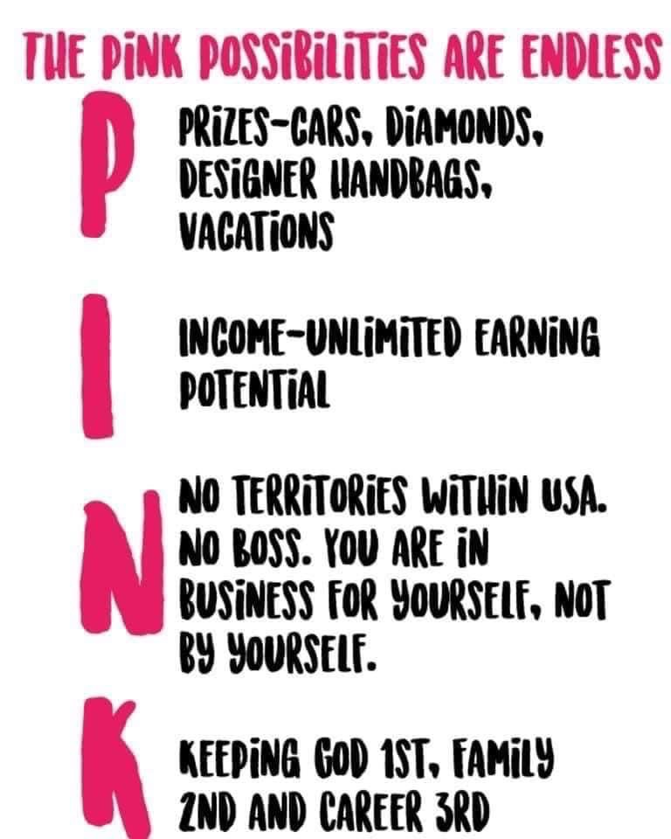

Message to send to guests the day before the party:

Hi Darla, happy Saturday! 😍 I’m so excited for Ash’s spa session on Facebook live tomorrow at 6pm! 🧖‍♀️ just wanted to check in to make sure you got your samples in the mail to use for the facial tomorrow? 🤞

When they say YES they got their samples, reply:

Fabulous! 🙌 save the samples until the party tomorrow & I’ll teach you step by step how to use them. You’ll get a 1/2 price lip gloss or lipstick if you join us live & interact during the party PLUS a gift from me if you send me a pic of your party paper afterwards too! 🥳

Message to send to hostess the day before the party:

Hi beautiful Ash! I’m so excited for your virtual pampering party tomorrow at 6pm! 😍

Below is a list of everyone who got samples for the party — if you have some time today or tomorrow before the party, can you send them all a message saying something like you can’t wait to see them on your Facebook live party tomorrow, it’s gonna be so much fun & thank them in advance for coming? It will definitely help your attendance for the party, thus that means more free products for YOU! ☺️

(Type guest names who received samples here)

Lead up post #26: (specific to the day before the party)

💄Introducing Mary Kay’s ✨ NEW! ✨ Mary Kay Unlimited™ Lip Gloss!!!

Upgrade your gloss experience with patent-pending technology that delivers a nontacky, nonsticky layer of shine. This next-generation gloss glides on smoothly with no drag and delivers instant moisture. Choose from 14 shades that work for every skin tone and any occasion, perfect for whatever your lips face next. It’s time for your lip gloss to glow up! 💄

Guess what?! 🎉 When you tune into Ash’s Spa Day tomorrow & interact with me on the LIVE party, you’ll get YOUR CHOICE of lip gloss or lipstick of your choice HALF PRICE! 😍

🎟 PRIZE ENTRY 🎟
Which color is your FAVORITE?!
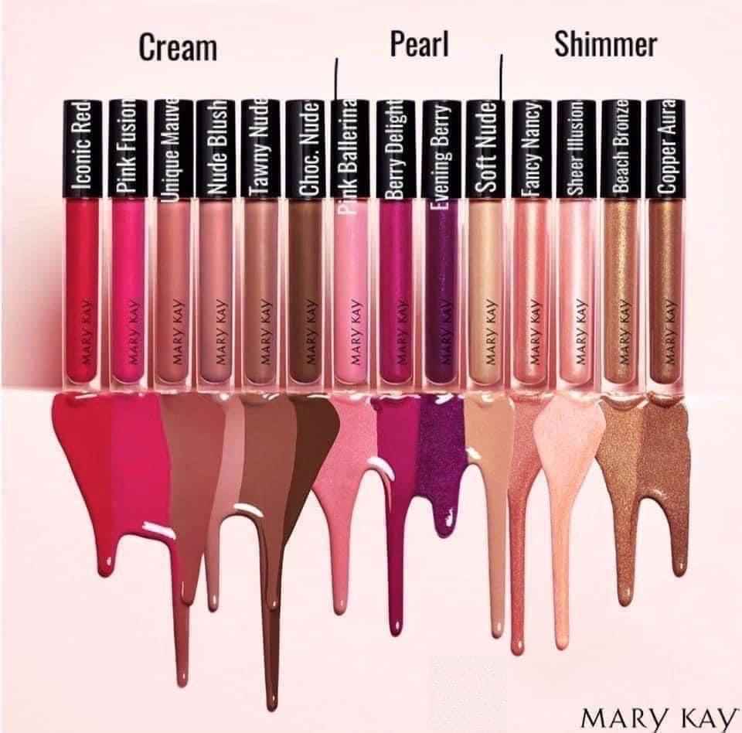

⭐️ On the day before the party, you’ll want to go through all of the pre-party posts & write down the guests name & number them 1- xxx so you have a list of everyone who commented to do the free product giveaway during the party ⭐️

Post the morning of the party: (also tag all guests who received samples in the post or in the comments of the post)

The day is FINALLY here!!! I am SOOO excited for Ash’s Spa Day TODAY at 6pm EDT!!! 🥳🥳🥳

Tune in right here in this group & you’ll see me going LIVE!! Don’t forget, JUST for showing up & commenting/participating, you’ll get your choice of lip gloss or lipstick 50% OFF!!! PLUS you’ll have the chance to win a FREE product giveaway!!! 💖💖💖

LET’S GOOOO!!! 🎉🎉🎉
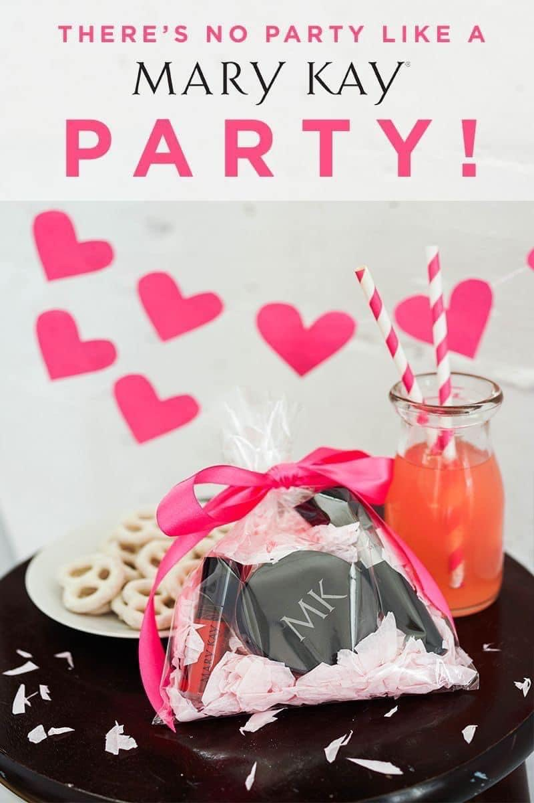

Message to send to guests the day of the party:

It’s spa party day!!! 🧖‍♀️😍🙌 I hope you’re as excited as I am!!! ☺️ just hop on over to Ash’s party group at 6pm & you’ll see me going live! 👉 (note to consultants/delete this out before sending the message — include the link to the group here. To find this, go to your group & click on the icon that looks like a shield at the top right corner of your group. Then scroll to the bottom and click on share group and copy the link)
https://www.facebook.com/groups/758164495209425

Don’t forget you get a gift from me + your choice of lipstick or lip gloss 50% off if you hop on & participate live PLUS you’ll also be entered in to win a monthly $200 cash giveaway too!!! I hope you can make it! 🎉

Message to send to hostess the day of the party:

So excited for your party today!!! 🎉 if you didn’t message all your guests yesterday, I would definitely recommend doing that today if you have time before the party!

Also — will you comment & interact with me throughout the party too to help keep the energy up please? 😍

Also just know at some point during the live party, I’m gonna ask you to pick a random number so I can do the free product giveaway from the comments leading up to the party too 😉

Post one hour before the party begins:

1 hour ‘til PARTY TIME!!! 🎉💋

Grab your favorite drink + your pampering package full of goodies + a couple wash cloths + a bowl of warm water + a pen & meet me here at 6pm EDT!!! 🧖‍♀️

💄 Remember when you interact with me on the live party, you can choose any lip gloss of your choice for half price! 🙌 (or lipstick if you’re not a gloss girl 😉)

Drop a GIF & tell us how excited you are! 👇
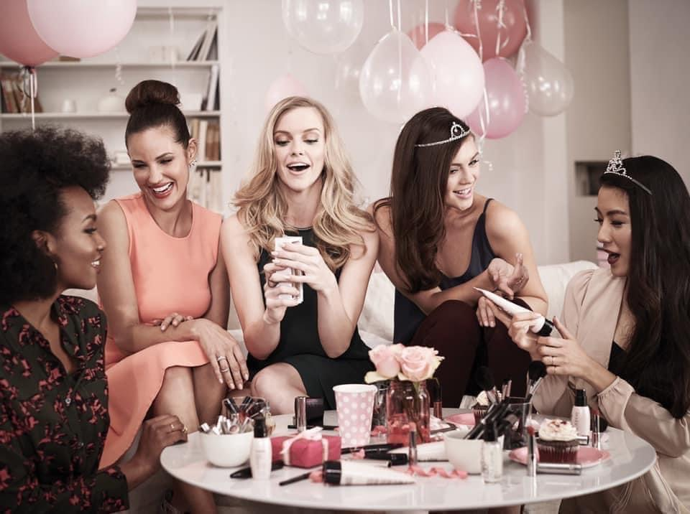

After party post: (be sure to include current calendar in the pics)

💕 Thank you SO MUCH for attending the virtual pampering party today! I had so much fun with you all & I so appreciate you coming to support your hostess with the mostest Ash Moore along with my small business & BIG dreams! 🥰

Ash’s party will be open through FRIDAY! 🎉

Don’t forget to send me a pic of your party paper and your answers to the 4 questions below to earn a gift from me! 💝

1. FREE - I would love to book a FB party with you to earn FREE products! 🆓
or
ME - no thank you! I was just here to pamper me! 🙋‍♀️

2. VIP — write down VIP if you’d like to be added to my VIP group & my mailing list to receive our new catalog in the mail once a quarter! 😍

3. Would you like to place an order from Ash’s party?
A = I want a Cadillac, Queen or Princess special deal
B = I do want to place an order but not for one of the special deals! (With this option, you get 1 half price item per set that you choose! So buy 1 set, get 1 item 50% off! Buy 2 sets, get 2 items 50% off, etc)
C = I was just here to be a cheerleader but I’m not buying anything 😉

🛍 You can PM me with your order, you can order from my website, or you can feel free to call or text me 614-519-6128!

Please note you will NOT see the party specials on my website. I will adjust your order total before processing it! 💕

www.marykay.com/lfreisthler

4. What is your interest in starting your own Mary Kay business?
A = ABSOLUTELY! Sign me up! Get a FREE charcoal mask for being a decision maker!
B = Borderline. I’m not a yes or a no — I’m unsure! Let’s chat more about it! 😊
C = I’d rather be a happy customer

💗💕💗💕💗💕💗💕💗💕💗💕💗💕💗💕

Here is the form to fill out to get yourself entered into our $200 CASH GIVEAWAY once you send me your party paper!👇👇👇
https://forms.gle/PunqVXhGftWG3CBs9
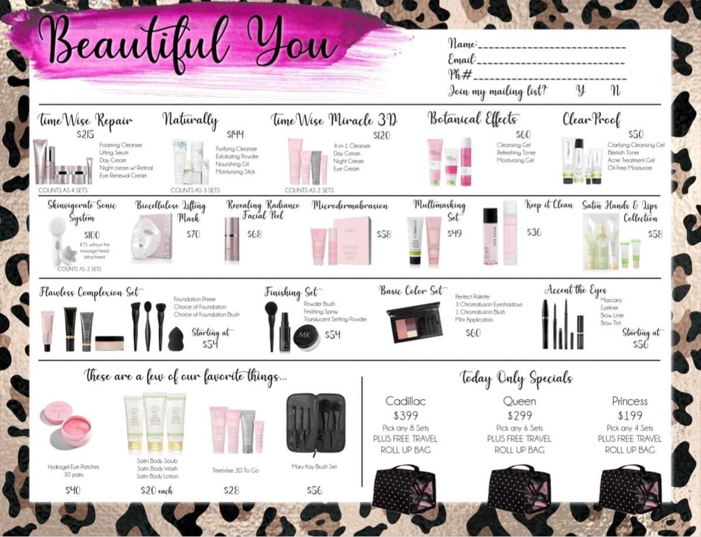
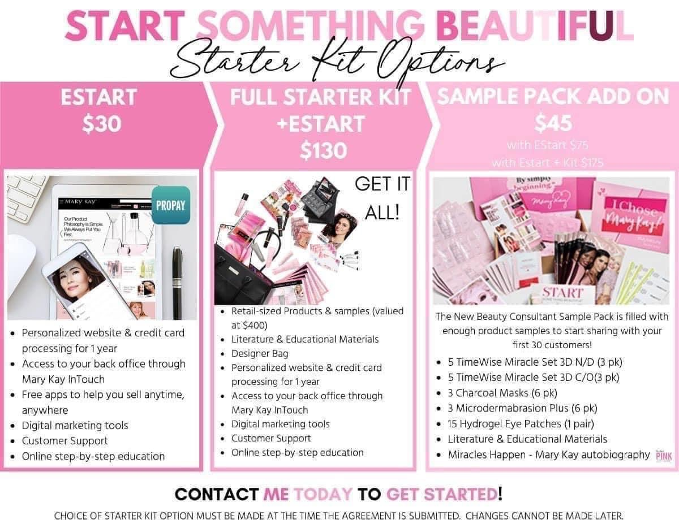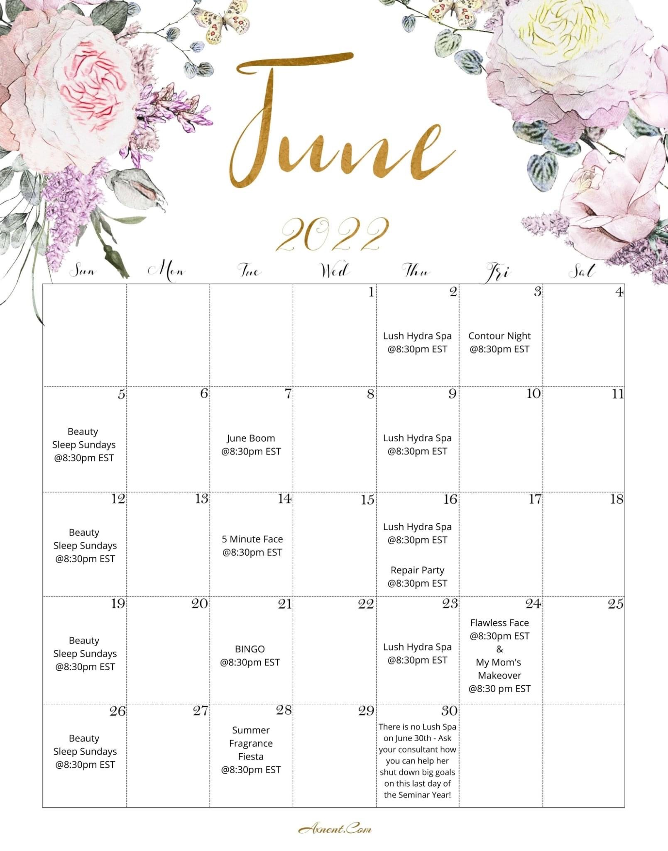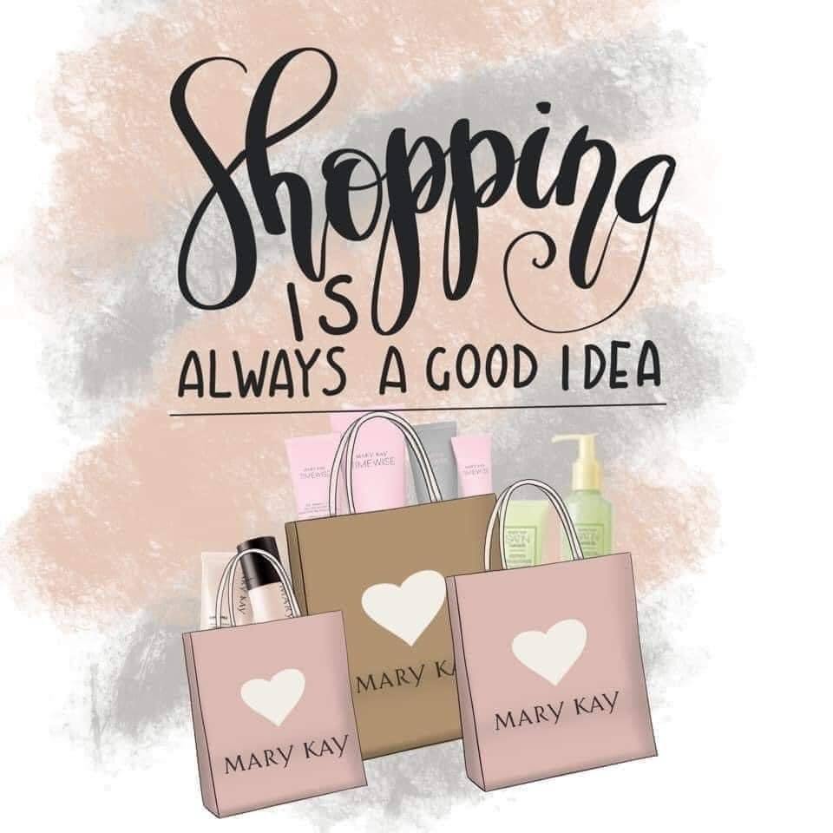

Put this in the comments on the after-party post:

(Tag everyone who attended live here) — don’t forget to send me a picture of your party paper to get a gift from me! 🎁

Also fill out the Google form above to be entered into the monthly $200 cash giveaway! 💰
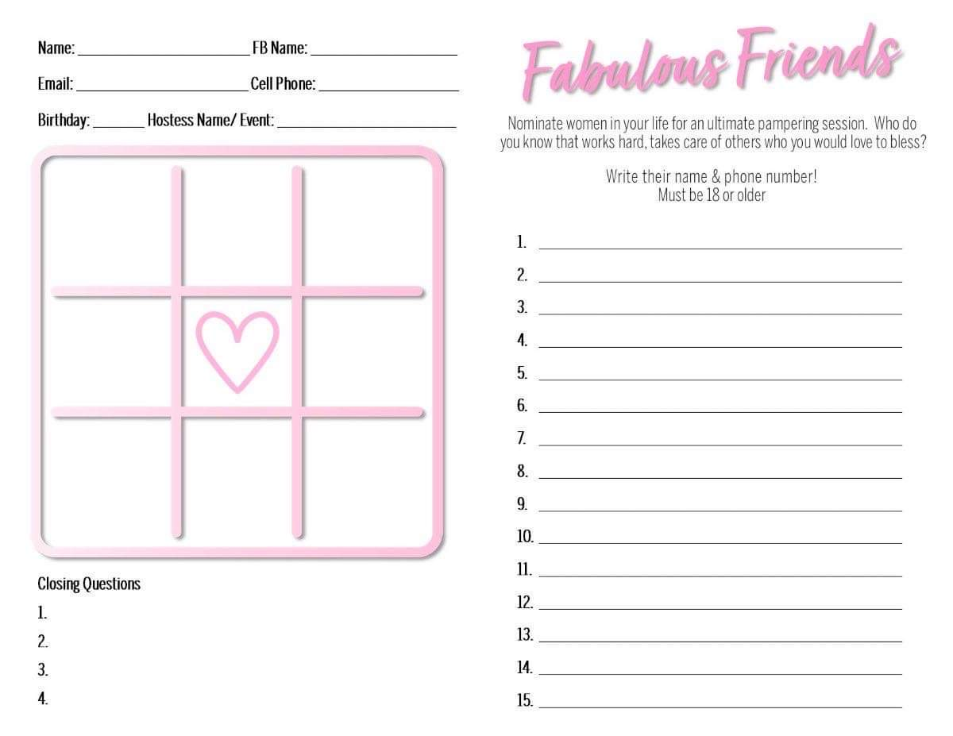

Message to send to guests who attended live:

Hey love! Thanks so much for attending the party! I hope you had fun, learned some new stuff & that your face is feeling amazing! What did you think of the facial? 😍

Also — if you send me a pic of your party paper, you get a gift from me! 🎁

⭐️ Helpful guide on what the 4 answers to the closing questions mean:

1) they want to host a party if they wrote FREE.

ME means they don’t.

2) if they wrote VIP = it means they want to be added to your mailing list to receive our new catalog “The Look” quarterly. Enter them in as customers under myCustomers on InTouch under business tools & you will add them to your preferred customer program enrollment next quarter to start receiving quarterly catalogs

3) if they wrote
A = they want a princess, Queen or Cadillac deal

B = they wanna place an order but not for a special (they get 1 half price item per set if they choose this option)

C = I’m not buying anything

4) if they wrote
A = they wanna join your team! Go to Intouch > business tools > online agreements > create an email invite to send them the link to sign up. You’ll need their name, email address & phone # to do this
B = they’re borderline. They’re not a yes or a no, but they’re thinking about joining. Let’s set up a quick 3-way chat with them to answer their questions about a MK biz!
C = they just wanna be a customer

Message to send to guests who received samples but couldn’t join live:

Hi Ashlee! We missed you on the party today! It was so much fun! 🥳

I’m in a face race contest for June so I have a HUGE goal to see 30 faces this month! I’ll be happy to honor the steal deals/specials from the party through Friday & I’ll give you a gift if you watch the party & give me your feedback so I can count you as a “face”! 😍

When do you think you can watch the replay in the next couple days so I can follow back up with you? ♥️

Hostess credit update/thank you for ordering post:

Thank you SO MUCH to (purchasing guest name) for your order! I so appreciate you & your support of my small business & big dreams!!! 😍

Ash Moore has earned $40 in FREE PRODUCTS for being a hostess so far!! 🥳

The party will be open until Friday! 🎉 Let’s see how much more free product we can earn Ash! 🙌
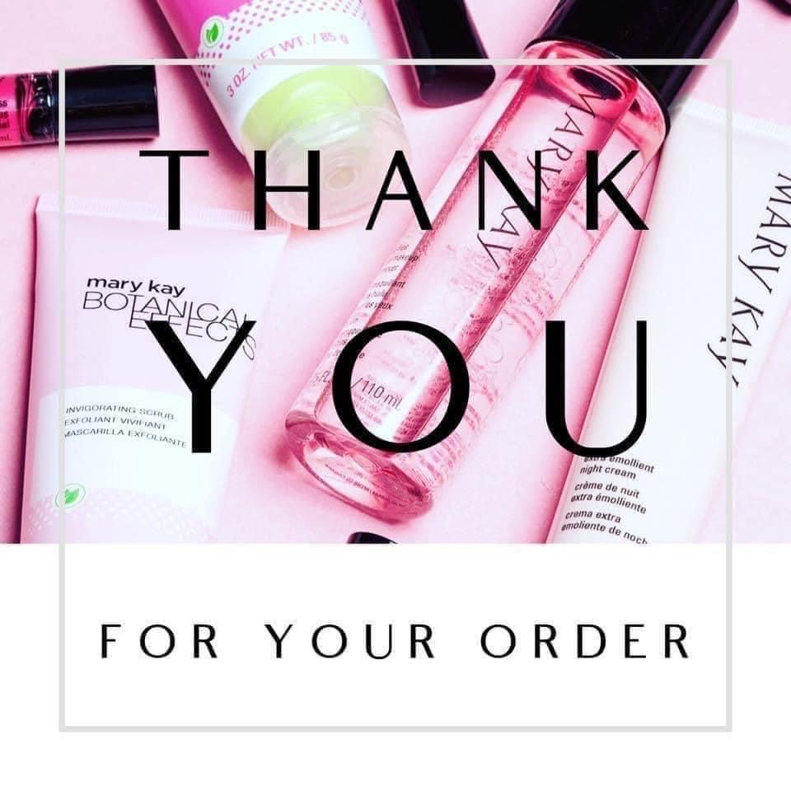

Hosting credit update/thank you for booking a party post:

(Name of guest who booked a party) just booked her own virtual party so Ash Moore just earned another $25 in FREE hostess credit!! 🎉 Can’t wait to help YOU earn some free products too, (name of guest who booked)!!! 💖

Ash is now up to $65 in FREE PRODUCTS from her party!!! 🥳

The party is still open until Friday! Let’s see how much more free product we can earn Ash! 🙌
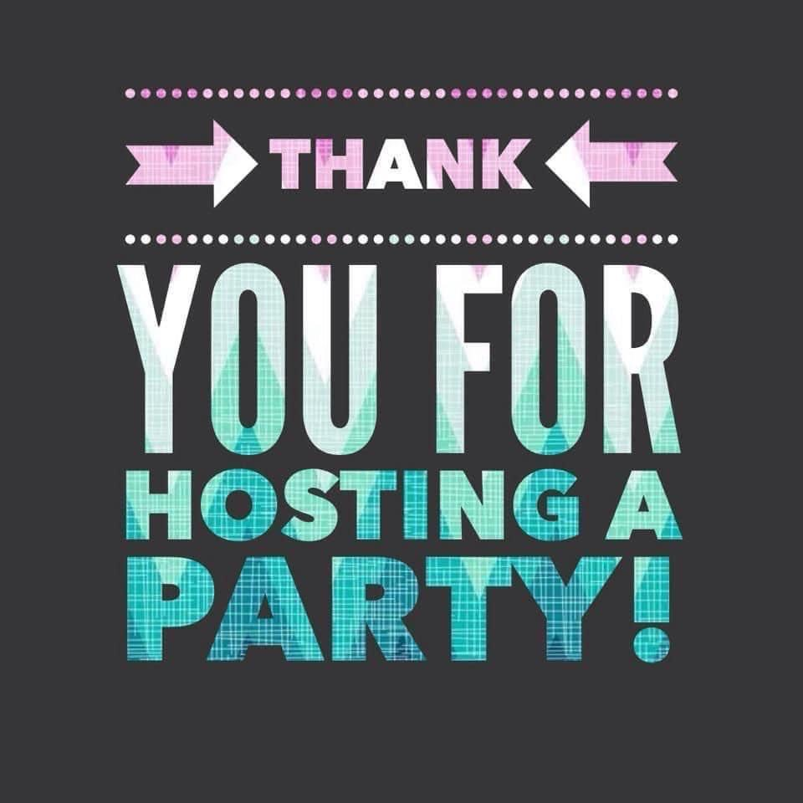

Hostess credit update/thank you for ordering post:

Thank you so much to (purchasing guest’s name) for your order & your support of my small business & BIG dreams!!! 🥰

Get this y’all! Ash Moore is officially up to $85 in FREE products from her party!!! 😍🙌 let’s help her cross over the $100 mark today, what do you say?!

The party is open until Friday!! 🎉🎉🎉
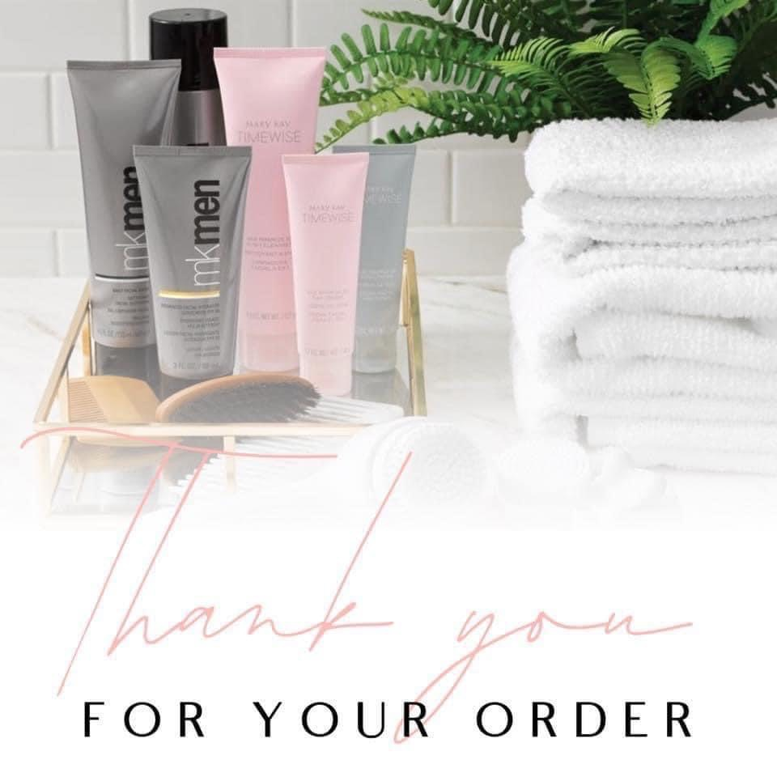

Hostess credit update/someone joined my team from the party post:

I’m SO excited to welcome (new team member’s name) to my Mary Kay team!!! 🥳 after attending this party, she decided to take a chance on herself to give a Mary Kay business a try! WOOHOO (name)! The sky is truly your limit! 💖

Because (new team member’s name) joined from this party, Ash Moore is now up to $110 in FREE products from hosting this party!!! 🎉🎉🎉

HOW EXCITING?! The party is still open until FRIDAY!! Let’s see how much more free product we can earn Ash! 🙌

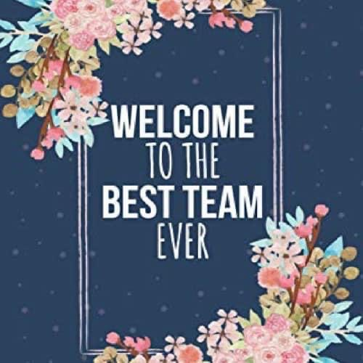

2-3 days after the party post:

🌸 It's not too late to help Ash earn extra hostess credit! If you decide to book your very own Virtual Beauty Experience party with me, Ash will earn an additional $25 in hostess credit and you will earn all of the goodies below (20% of party sales & $25 for every friend that books from your party or joins my team)!

Ash is already up to $125 in FREE PRODUCTS from hosting this online party! 🥳 And YOU COULD, TOO! ALL you do is invite your friends to join a Facebook group & I do all the rest! Let me know if you’d like to host your own virtual beauty experience to earn tons of 🆓 goodies! 💖
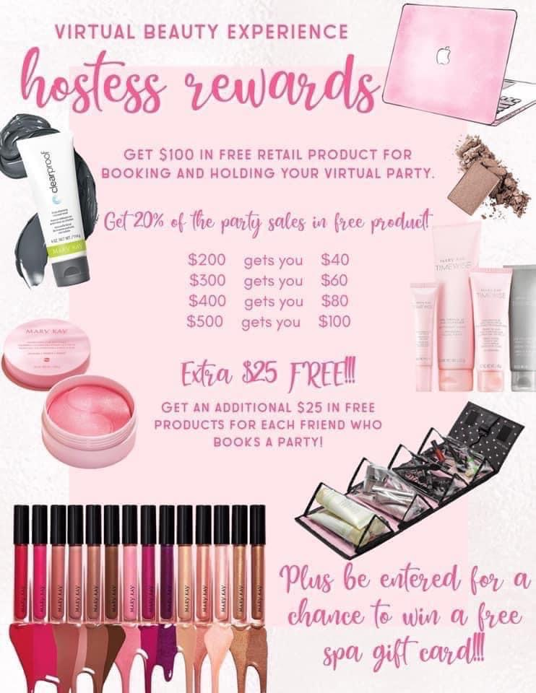

More thank you for ordering images:

